Belt and Road Reboot: Beijing’s Bid to

De-Risk Its Global Infrastructure Initiative

# Chapter 4: Reputational Rehabilitation on the Belt and Road

November 2023

Bradley C. Parks, Ammar A. Malik, Brooke Escobar, Sheng Zhang, Rory Fedorochko, Kyra Solomon, Fei Wang, Lydia Vlasto, Katherine Walsh, and Seth Goodman



# Chapter 4: Reputational Rehabilitation on the Belt and Road

### Section 1: China’s quest for soft power during the BRI era

Great powers use aid and credit to expand their global inﬂuence.[305] These tools of economic statecraft can be particularly useful for winning support from developing countries. During the Cold War, the Eastern and Western blocs used grant-giving and lending instruments to promote their competing ideologies and strengthen alliances around the world (Heurlin 2020). China’s BRI stands out as another striking example of this approach during the 21st century. Beijing has attempted to bolster its global inﬂuence by offering demand-responsive infrastructure ﬁnancing and rapid project delivery to developing countries (Dreher et al. 2022). Prior to the unveiling of the BRI, Beijing tried to keep a relatively low proﬁle as an international donor and lender, adhering to Deng Xiaoping’s “hide your capabilities and bide your time” principle. However, the BRI marked an important shift. China became more proactive about cultivating its brand and broadcasting positive messages about its overseas activities. It did so by placing signage at project sites, organizing high-proﬁle ceremonies to celebrate the commencement and completion of projects, cultivating relationships with journalists to encourage positive media coverage of project accomplishments, and forging content-sharing partnerships with radio stations, television channels, and newspapers (Custer et al. 2018, 2019; Wellner et al.

2023).

Washington sees the BRI as Beijing’s attempt to “reshape the international order [and] [...] the rules of the road” by “us[ing] its economic power to coerce countries” (White House 2022). The 2022 U.S. National Security Strategy emphasizes the importance of “out-competing China” and calls upon government agencies to “partner with, support, and meet the economic and development needs of partner countries” (White House 2022). However, given the difﬁculty of competing dollar-for-dollar with Beijing, Washington is increasingly aware of the fact that it will need to carefully select countries, sectors, and delivery instruments that offer the greatest return on investment.

U.S. policymakers have also demonstrated interest in understanding the causes and consequences of BRI backlash—and Beijing’s response to it. On its 10th anniversary, the BRI faces an array of reputational challenges in host countries where enthusiasm for the initiative has waned. Debt repayment challenges (discussed in Chapter 2) and ESG problems related to infrastructure project implementation (discussed in Chapter 3) have led a growing number of LICs and MICs to reevaluate the risks and rewards of continued participation in Beijing’s “project of the century” (Horigoshi et al. 2022).

In this chapter, we seek to explain when, where, and how Chinese grant- and loan-ﬁnanced projects have become reputational assets or liabilities for China. We also examine how Beijing has recalibrated its strategies and tactics in countries where it has encountered public antipathy, unfavorable media sentiment, or insufﬁcient support among governing elites. With data on public opinion, media sentiment, elite support, and Chinese grant and loan commitments during the ﬁrst eight years of the BRI era (2014-2021), we use an “action-reaction” framework to examine how soft power gains and losses in LICs and MICs during the early years of the initiative (2014-2017) inﬂuenced Beijing’s responses in the so-called “BRI 2.0” era (2018-2021).

#### The pursuit of soft power for foreign policy advantage

States frequently use non-coercive tools—or so-called soft power instruments—to win the support of foreign countries on issues of major national importance (Nye 2004; Goldsmith and Horiuchi 2012; Goldsmith et al. 2014; Guiso et al. 2009; Rose 2016, 2019).[306] For China, these issues include Taiwan, Tibet, Xinjiang, Falun Gong, human rights, and maritime claims in the South China Sea (Flores-Macías and Kreps 2013; Kastner 2016; Strüver 2016, 2017; Custer et al. 2018).

Maintaining international support for the BRI is also a key priority. In October 2021, we observed Beijing’s readiness to manage reputational risk related to its ﬂagship, global infrastructure initiative. Within two days of the release of an AidData report on public debt exposure to China, a leading English daily in Pakistan, *Dawn*, wrote a hard-hitting editorial calling for greater transparency in the planning and ﬁnancing of the China-Pakistan Economic Corridor (CPEC).

Five days later, in response, two Cabinet-level ministers conducted a live press conference on national television in which they presented a point-by-point response to the editorial and the report (Malik et al. 2021; Dawn 2021). During subsequent meetings with senior ofﬁcials in Pakistan, we learned that the press conference was organized in part due to pressure from the Chinese embassy, which had expressed frustration at the “public relations impacts” resulting from a rare instance of negative press coverage about the CPEC.[307]

Beijing uses a wide array of soft power investments—including scholarship programs that allow foreign nationals to study in China, training programs that expose foreign government ofﬁcials to China’s policy positions, junkets for foreign journalists to visit China and learn about its experiences and perspectives, and political party outreach and capacity building activities—to rally international support for its priorities and policy positions. According to Dong and Chapman (2008: 162), China has provided thousands of university scholarships to African students each year with the aim of “training future leaders [...] who might serve as opinion leaders once back in their home countries.” In an analysis of Beijing’s effort to cultivate relationships with African political parties, Aiping (2015) ﬁnds that African countries frequently dispatch delegations to China to learn more about its model of economic development and system of governance, and that the Communist Party of China (CPC) uses these exchanges to extol the virtues of the ruling party maintaining internal stability to promote long-run economic growth and development.

Anecdotal evidence suggests that these soft power investments may be effective. Consider, for example, the cohort of countries that agreed to abstain on a key UNGA vote related to Russia’s invasion of Ukraine.[308] On March 2, 2022, UNGA passed a resolution condemning Russia’s aggression and calling on it to “immediately, completely and unconditionally withdraw all of its military forces from the territory of Ukraine.” 141 countries voted in favor of the resolution, 5 countries voted against it, and another 35 countries abstained. China abstained and many of its largest aid and credit recipients—including Angola, Bangladesh, Bolivia, Burundi, Central African Republic, Congo-Brazzaville, Cuba, El Salvador, Ethiopia, Gabon, Guinea, Iran, Kazakhstan, Kyrgyzstan, Laos, Mongolia, Mozambique, Namibia, Pakistan, South Africa, Sri Lanka, Sudan, Tajikistan, Togo, Uganda, Uzbekistan, Vietnam, and Zimbabwe—followed suit (White and Holtz 2022).

Yet great powers do not use soft power instruments merely to secure international support on discrete policy issues. They also strive for deeper ideological alignment and widespread admiration of their economic development and governance models (Repnikova 2022). Effective, long-term soft power projection requires *attractional* inﬂuence: resonant ideas and values that shape how governing elites in other countries diagnose problems, think about cause-and-effect relationships, identify desirable policy outcomes, assign priority among competing objectives, and determine how policies should be formulated and implemented (Kroenig et al. 2010; Atkinson 2010).

For many of China’s target audiences in the Global South, its model of economic development is attractive because of its apparent success: it successfully lifted 680 million people out of poverty in a generation (Ravallion 2009; Lin and Wang 2014).[309] China’s model, which prioritizes the rapid installation of large-scale physical infrastructure via state-led investment, is central to the way that it administers its overseas grant-giving and lending program (Ansar et al. 2016).[310] This approach supposedly allows countries to leapfrog the process of establishing liberal institutions and democratic values, which were prerequisites for economic and social progress in Western countries (Naughton and Tsai 2015).

For political leaders seeking reelection within four- to ﬁve-year cycles and autocrats vying for legitimacy on the basis of performance, China’s model of economic development can be especially compelling. Arthur Mutambara, Zimbabwe’s former Deputy Prime Minister, told the *Wall Street Journal* in 2011 that “China is my favorite country. [...] China's model is telling us you can be successful without following the Western example” (Wonacott 2011). Several years earlier, Abdoulaye Wade, the former President of Senegal, admonished Western aid agencies and multilateral development banks for their insensitivity to the conditions facing policymakers in developing countries and praised China’s model: “China’s approach to our needs is simply better adapted than the slow and sometimes patronizing post-colonial approach of European investors, donor [agencies] and nongovernmental [organizations]. [...] I am a ﬁrm believer in good governance and the rule of law. But when bureaucracy and senseless red tape impede our ability to act—and when poverty persists while international functionaries drag their feet—African leaders have an obligation to opt for swifter solutions” (Wade 2008).

#### The effectiveness of China’s soft power instruments

But China’s soft power playbook goes beyond bankrolling and building big-ticket infrastructure projects. Not unlike Western powers, it deploys a toolkit that includes cultural diplomacy through Confucius Institutes, exchange diplomacy using student scholarships and journalist visits, and elite-to-elite diplomacy in the form of leadership visits (Benabdallah 2021; Custer et al. 2018). Beijing has also put in place a well-resourced strategic communications strategy with “distinctive” Chinese characteristics (Shambaugh 2015; Snow 2022). It has dramatically expanded the global reach of ofﬁcial media organizations, such as Xinhua News Agency and China Radio International.[311] China’s messaging operations are, in turn, buttressed by content-sharing partnerships with local media, which republish stories carrying ofﬁcial Chinese narratives (Custer et al.

2019).

A growing body of statistical evidence suggests that China has effectively utilized soft power instruments to inﬂuence public opinion, media sentiment, and the foreign policy priorities of governing elites, albeit with varying degrees of success (Brazys and Dukalskis 2019; Eichenauer et al. 2021; Blair et al. 2022a; Dreher et al. 2022; Wellner et al. forthcoming, 2023; Asmus et al. forthcoming). Wellner et al. (forthcoming) ﬁnd that, on average, the completion of each additional Chinese development project leads to a 3 percentage point increase in public support for the Chinese government in the short term, although this effect erodes over time.[312] Brazys and Dukalskis (2019: 557) provide evidence that geographical proximity to an active Confucius Institute “signiﬁcantly and substantively improves the tone of media reporting about events relevant to China.”

The authorities in Beijing reportedly value more favorable media sentiment and public sentiment because they believe it can “ﬁlter up and inﬂuence elite policy to be more amenable to [their own] interests” (Brazys and Dukalskis 2019: 567). However, Beijing also seeks to directly inﬂuence the foreign policy priorities of governing elites. Dreher et al. (2022) provide evidence that a 10% increase in voting alignment with China in the UN General Assembly yields a 276% increase in aid and credit from China, on average.[313] These results suggest that Beijing, like some of its rivals, uses its foreign aid and credit to encourage and/or reward countries to support its foreign policy positions.[314]

Yet much remains unknown about China’s soft power strategy in the Global South. Is Beijing responsive to soft power gains or losses vis-à-vis the U.S.? What types of reputational liabilities or assets lead to competitive responses? Where, when, and how is Beijing using its development ﬁnance instruments to make soft power gains?

Leveraging the broad temporal and geographical coverage of the 3.0 version of AidData’s GCDF dataset, we examine these questions with an “action-reaction” framework. Based on China’s prior responses to changes in public opinion, media sentiment, and elite support in LICs and MICs, we seek to anticipate where and how China will mount competitive responses in the future.[315] We place special emphasis on understanding how China allocates limited competitive resources across “safe bet,” “toss-up,” and “moonshot” countries.

### Section 2: Vying for soft power: China’s play for public opinion, media sentiment, and elite support

Our action-reaction framework evaluates Beijing’s aid and credit allocation decisions during the late BRI period (2018-2021) after it observed various changes on three measures of soft power during the early BRI period (2014-2017): public support for the Chinese government, as measured via the

Gallup World Poll (GWP); the favorability of media coverage related to the Chinese government, as measured via the Global Database of Events, Language, and Tone (GDELT); and elite support for China’s foreign policy positions, as measured via UNGA voting alignment with China.

In Chapter 1, we documented that, in the Global South, these three soft power metrics moved in varying directions over the ﬁrst eight years of the BRI (2014-2021). During the early BRI period, the contest for international public opinion between Washington and Beijing remained neck and neck. However, public support for China fell sharply by 16 percentage points between 2019 and 2021. In terms of media favorability, after years of maintaining a competitive edge, Beijing lost signiﬁcant ground to Washington during the late BRI period; its favorability advantage over Washington shrank to a razor-thin margin. China did relatively well at maintaining elite support for its foreign policy positions, as measured by the extent to which LICs and MICs aligned their UNGA votes with China. However, we also identiﬁed some grounds for concern in BRI participant countries, as governing elites in this cohort took foreign policy positions (in UNGA) that were increasingly out of alignment with those of China during the late BRI period.

Our analysis in Chapter 1 also revealed that, while the battle for hearts and minds between China and the U.S. was a “toss-up” during the early BRI period, it became signiﬁcantly more competitive during the late BRI period. Washington made more reputational gains at Beijing’s expense—than vice-versa—during this period. This was especially true in the contest for international public opinion, where almost 85% of the country-level changes in public opinion represented relative losses for China.

We now extend the analysis by focusing on the relative gains and losses experienced by both powers on an annual basis across three soft power measures during the early BRI period. We designed our analytic approach in recognition of two realities. First, great power competition for soft power is generally considered to be a zero-sum game by the participants.[316] Second, events (“shocks”) at local, regional, and global levels can simultaneously affect overseas support for all great powers.[317] To address these realities, we ﬁrst measure absolute year-on-year (YoY) changes to our three measures of soft power at the country level (single delta) for each great power (China and the U.S.). We then measure the difference (double delta) between the changes that China experienced and the changes that the U.S. experienced (see Box 4a).

These double delta measures allow us to identify when and where China experienced (a) larger losses (or smaller gains) than the U.S., and (b) larger gains (or smaller losses) than the U.S.[318]

This methodological approach also makes it easier to think about how Beijing allocates scarce resources across different categories of countries to advance its soft power objectives. When a great power allocates scarce resources in pursuit of grassroots, media, or elite support, it must make *risk-adjusted reward calculations*—by balancing the magnitude of a potential soft power gain in a given jurisdiction against the likelihood of success in that setting (Asmus et al. forthcoming). As a general rule, it can make smaller gains in places where the probability of success is high (safe bet territory), or it can venture into more challenging places where the probability of success is low (moonshot territory) but the opportunity to make a large gain (at the expense of a rival) is high.[319] In recognition of this tradeoff, we organize our analysis around four cohorts: safe bet countries, toss-up countries that lean toward China, toss-up countries that lean toward the U.S., and moonshot countries (based on the data sources and methods described in Box 4a).

**Box 4a: How AidData measures relative gains and losses in Chinese soft power**

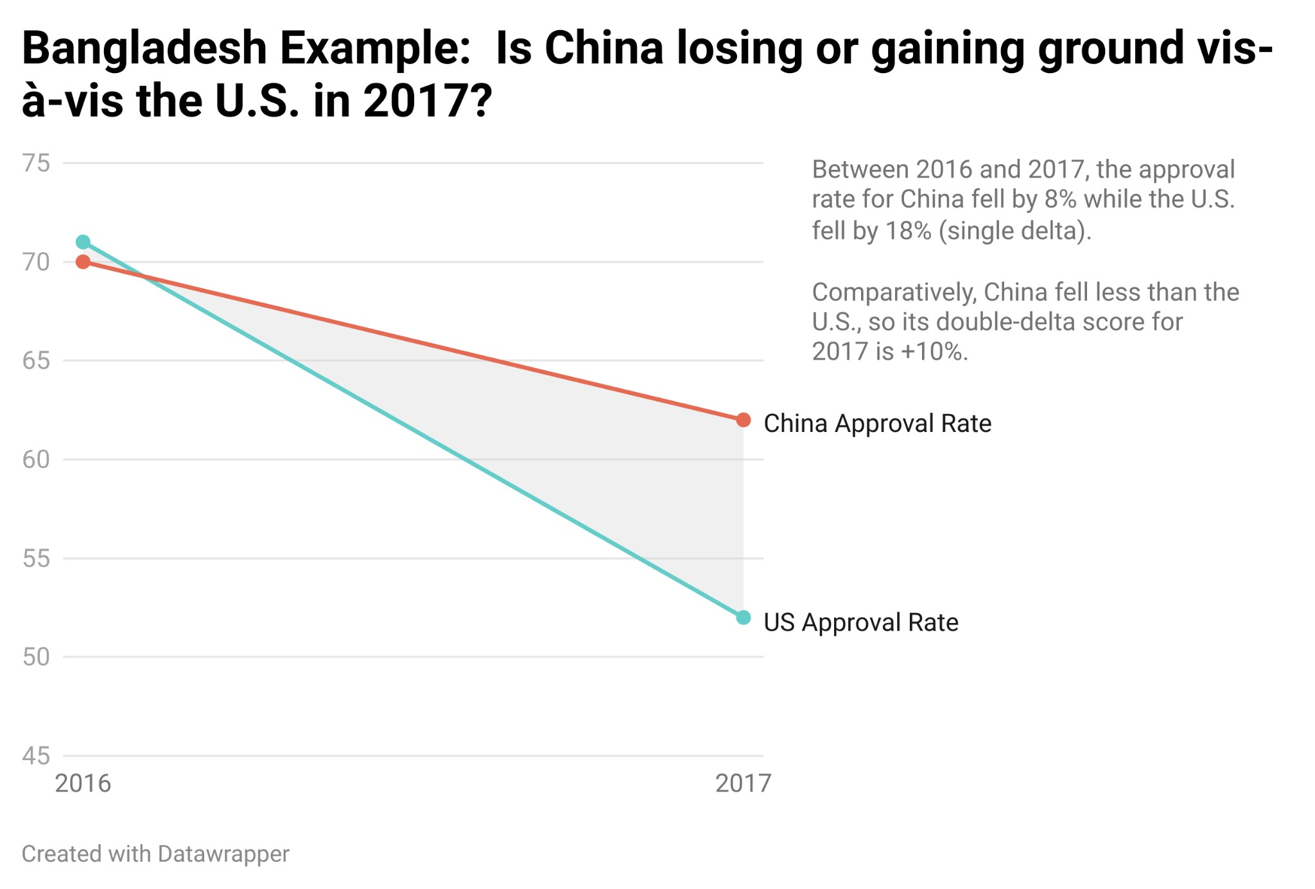

For all three measures of soft power in LICs and MICs (public opinion, media sentiment, and elite support), we adopt an identical approach to measure relative gains and losses by China vis-à-vis the U.S. at the host country level. In order to explain our method of measurement, we describe how it is applied to one soft power indicator (public opinion) and one host country (Bangladesh). We take the following steps:

Step 1: Use Bangladesh’s annual public approval ratings (from GWP) to calculate the year-on-year change (single delta: t0 - t1) for China and the U.S. for each year of the early BRI period.

Step 2: Calculate the difference between the “single delta” in China’s public approval rating and the “single delta” in the U.S. public approval rating for each year. The resulting “double delta” (China-U.S.) measure provides an indication of whether and to what extent China gained or lost ground at the expense of the U.S. The larger the size of a (positive) double delta, the greater the size of the gain that China made at the expense of the U.S.—or vice versa. Figure 4.1 provides a visual representation of how this calculation works for one soft power indicator (GWP) in Bangladesh between 2016 and 2017.

Figure 4.1: Bangladesh example: Is China losing or gaining ground vis-à-vis the U.S. in 2017?

## Figure 4.1

Step 3: Calculate the average annual relative change (i.e., average annual double delta) in public approval over the early BRI period (2014-2017). Averaging over the 2014-2017 period effectively measures whether China gained more ground overall than the U.S.—or vice versa—during the

early BRI period. Table 4.1 provides the full calculation for Bangladesh, where 1.6 is the ﬁnal score for Bangladesh during this time period.

|  |  |  |  |  |  |  |  |  |
| --- | --- | --- | --- | --- | --- | --- | --- | --- |
| **Table 4.1**  **Bangladesh example: Calculating an average double-delta score for soft power measures** | | | | | | | | |
| **Year** | **China Approval Rate** | | **China Single Delta** | | **U.S. Approval Rate** | **U.S. Single Delta** | | **China-U.S. Double Delta** |
| 2013 | 69.6 | | - | | 66.2 | - | | - |
| 2014 | 47.5 | | -22.1 | | 44.9 | -21.3 | | -0.817 |
| 2015 | 55.6 | | +8.1 | | 55.5 | +10.6 | | -2.52 |
| 2016 | 70.4 | | +14.8 | | 70.5 | +15.0 | | -0.164 |
| 2017 | 62.0 | | -8.4 | | 52.1 | -18.4 | | +9.99 |
| Average (2014-17) | 58.8 | | -1.9 | | 55.7 | -3.5 | | 1.6 |
|  | | | | | | | | |
| Safe Bets  (75-100th percentile) | | **Toss-Ups - Leaning China**  (50-74.9th percentile) | | **Toss-Ups**  (25-49.9th percentile) | | | **Moonshots**  (0-24.9th percentile) | |
| Step 4: Repeat this process for all country-year pairings, rank countries based on their average annual double delta values during the early BRI period, and divide the global distribution of LICs and MICs into four categories:   * **Safe bets**: The top quartile (75th to 100th percentile) of countries where China made the largest gains at the expense of the U.S. during the early BRI period. | | | | | | | | |

* **Toss-ups (leaning China)**: Countries that fall between the 50th to 74.9th percentile represent competitive jurisdictions where China made relatively small gains at the expense of the U.S. during the early BRI period.320
* **Toss-ups**: Countries that fall between the 25th to 49.9th percentile represent competitive jurisdictions where China made negligible gains at the expense of the U.S. during the early BRI period—or the U.S. made relatively small gains at the expense of China during the early BRI period.
* **Moonshots**: The bottom quartile (0 to 24.9th percentile) of countries where the U.S. made the largest gains at the expense of China during the early BRI period.

#### Public opinion

To understand China’s public opinion gains and losses vis-à-vis the U.S. during the early BRI years, we ﬁrst rank-order 104 LICs and MICs (for which GWP data are available) according to our double delta measure (see Figure 4.2). The observed values on this measure range from -18 pp in Malaysia to +60 pp for Libya. We then calculate a percentile ranking for each country in the global distribution. These rankings are subsequently used to assign each country to one of four categories (described in Box 4a): safe bets (75th to 100 the percentile), toss-up leaning China (50th to 74.9th percentile), toss-up (25th to 49.9th percentile), and moonshots (0 to 24.9th percentile).

**Figure 4.2**

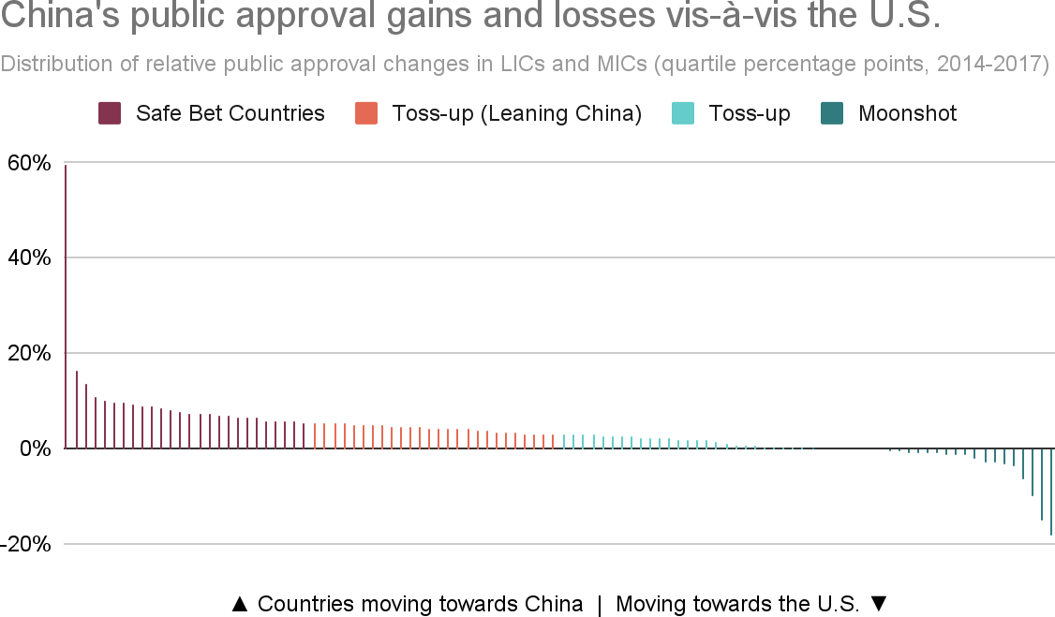

*Notes: The relative change calculation is based on the “double delta” measure that is described in Box 4a. Based on its position in the global distribution, each country is assigned to one of four categories: safe bet, toss-up (leaning China), toss-up, or moonshot (as described in Box 4a).*

As Figure 4.2 demonstrates, during the early BRI years, China achieved gains at the expense of the U.S. in two-thirds of all host countries with GWP public opinion data. The average double delta in this cohort was +3 pp. There are several reasons why the U.S. may have suffered soft power losses during this period. One is President Trump’s election and the “America First” agenda, which brought about a period of global retrenchment. Another is President Xi’s contrasting approach, which sought to establish “win-win” partnerships and new “connectivities” with the Global South through the BRI (Rolland 2017).[321]

Notwithstanding Beijing’s overall success in making public opinion gains at the expense of Washington, there were some notable exceptions. Negative double deltas in Malaysia (-18 pp), Vietnam (-10 pp) and Niger (-2 pp) indicate signiﬁcant relative losses for China. During the same period of time, China registered large, positive double deltas in Jamaica (+16 pp), Namibia (+10 pp), and Egypt (+8 pp). In at least two-thirds of countries, we see evidence of robust competition between Washington and Beijing, with average double delta values in the -5 to +5 pp range.

While every country context is unique, public approval levels appear to be sensitive to certain factors, such as changes of government from pro-China incumbents to new political leaders who view Beijing with greater skepticism (e.g., Malaysia), ongoing or worsening territorial disputes with China (e.g., Vietnam), and major changes in levels of aid or lending from a great power (e.g., Jamaica). The case studies in Section 4 demonstrate that the extent to which policymakers in Beijing use development ﬁnance and public diplomacy tools to respond to such changes depends on their perceptions of the strategic value of a given country.

#### Media sentiment

We follow the same double delta approach to measure the media sentiment gains and losses that China achieved vis-à-vis the U.S during the early BRI period.[322] According to Figure 4.3, Beijing achieved gains at the expense of Washington in 79.4% of (104 out of 131) host countries for which GDELT data are available. This pattern is consistent with previous research that suggests the launch of the BRI, together with Beijing’s strategy of ramping up public diplomacy efforts, including grassroots media management, generated more positive media coverage about China’s government (Custer et al. 2019; Brazys and Dukalskis 2019).

Figure 4.3 also demonstrates that China achieved the biggest relative gains in the Democratic Republic of the Congo (+2.8 pp), Vanuatu (+1.8 pp), and Tajikistan (+1.5 pp), while its largest relative losses took place in Comoros (-2.6 pp), Tunisia (-1.4 pp), and Dominica (-1 pp). Across the entire global distribution, the average double delta size during the early BRI period was +0.54.

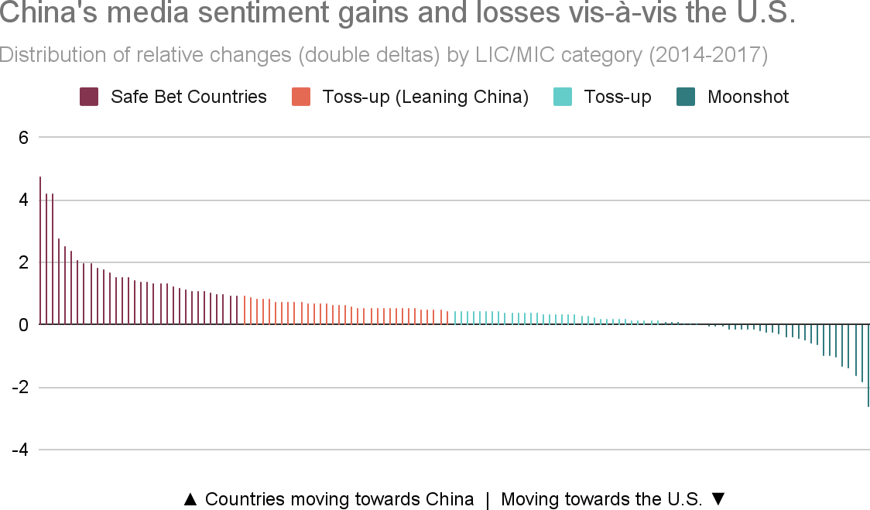

**Figure 4.3**

*Notes: The relative change calculation is based on the “double delta” measure that is described in Box 4a. Based on its position in the global distribution, each country is assigned to one of four categories: safe bet, toss-up (leaning China), toss-up, or moonshot (as described in Box 4a).*

#### Elite support

As a member of the Global South, China’s voting patterns in the UNGA are closely aligned overall with those of developing countries—especially on issues related to human rights and national sovereignty (Fung and Lam 2022).[323] However, as Figure 4.4 demonstrates, unlike public approval and media sentiment where Beijing achieved signiﬁcant gains at Washington’s expense during early BRI years, UNGA voting alignment is a measure of soft power for which we observe the opposite trend: governing elites in LICs and MICs moved their foreign policy positions into closer alignment with China in only 28% of the 107 countries (for which UNGA voting alignment data are available).[324] China experienced soft power losses vis-à-vis the U.S in India (-0.14 pp), Pakistan (-0.12 pp), Brazil (-0.09 pp), Venezuela (-0.05 pp), Mali (-0.16 pp) and Rwanda (-0.14 pp). The countries that handed relative soft power gains to China included the Paciﬁc island nations of Kiribati (0.4) and Micronesia (0.34), and several mid-sized countries in Latin America including Panama (0.18) and Paraguay (0.12).

At the same time, these changes are important to understand in their correct context. The vast majority of LICs and MICs remained far more strongly aligned with China than the U.S. in the UNGA in *absolute* terms. Across all UNGA votes cast between 2000 and 2021, we ﬁnd that LICs and MICs on average aligned with China 75.6% of the time, as compared to 23.1% with the U.S.

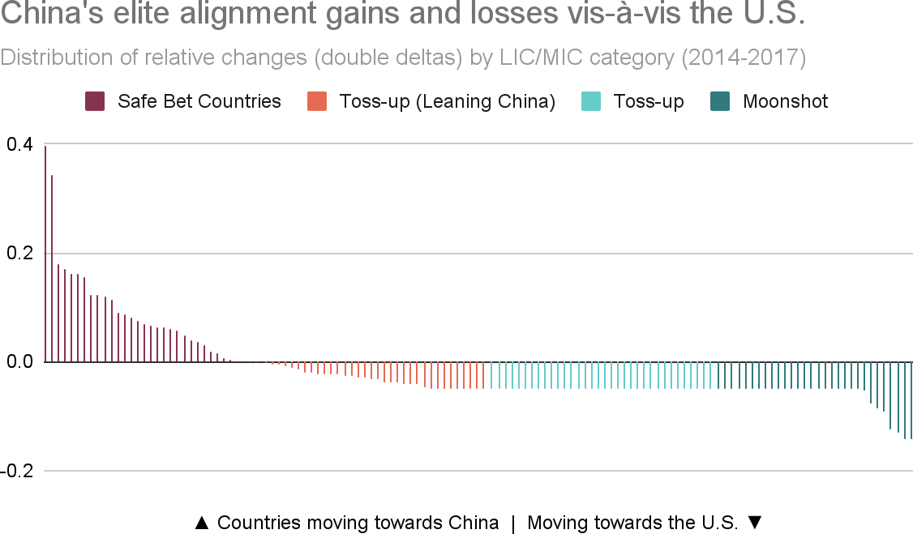

**Figure 4.4**

*Notes: The relative change calculation is based on the “double delta” measure that is described in Box 4a. Based on its position in the global distribution, each country is assigned to one of four categories: safe bet, toss-up (leaning China), toss-up, or moonshot (as described in Box 4a).*

### Section 3: From observations to reactions

Having measured the soft power gains and losses that China experienced during the early BRI period, we now turn our attention to the second part of our action-reaction framework: Beijing’s late BRI responses to soft power changes during the early BRI period. We do so by analyzing a new feature of the 3.0 version of AidData’s GCDF dataset: development ﬁnance commitment data for all LICs and MICs between 2018 and 2021.

#### Quantifying Beijing’s strategic prioritization: The expectation versus reality framework

The next step in our analysis is to determine if there is evidence of Beijing strategically allocating aid and credit during the late BRI period to pursue its soft power objectives. We do so by analyzing whether Beijing favored or disfavored any speciﬁc soft power country cohorts between 2018 and 2021, relative to a reference point of aid and credit allocations that are based on the cross-country distribution of economic need.[325] In cases where we observe large differences between the expected size of Chinese development ﬁnance commitments (based on economic need) and the observed size of Chinese development ﬁnance commitments, we argue that such differences may reﬂect strategic decisions by Beijing to prioritize or de-prioritize a country for soft power purposes.

**Table 4.2**

## Expected versus observed allocation of Chinese development ﬁnance by soft power cohort

|  |  |  |  |  |  |  |  |  |  |
| --- | --- | --- | --- | --- | --- | --- | --- | --- | --- |
| **Category** | **Public Opinion** | | | **Media Sentiment** | | | **Elite Support** | | |
| Expected (%) | Observed (%) | *Difference (pp)* | Expected (%) | Observed (%) | *Difference (pp)* | Expected (%) | Observed (%) | *Difference (pp)* |
| **Safe Bets** | 15 | 17 | *+2* | 10 | 9 | *-1* | 7 | 30 | *+22* |
| **Toss-Up - Leaning China** | 18 | 48 | *+29* | 19 | 48 | *+29* | 17 | 23 | *+6* |
| **Toss-Up** | 22 | 15 | *-7* | 36 | 35 | *-1* | 28 | 16 | *-12* |
| **Moonshot** | 43 | 16 | *-27* | 34 | 7 | *-27* | 47 | 31 | *-16* |

*Notes: This table illustrates which soft power cohorts (safe bet, toss-up leaning China, toss-up, and moonshot) received relatively more or less development ﬁnance from China during the late BRI period (2018-2021) compared to an expected allocation. The expected percentages for each cohort and soft power measure (public opinion, media sentiment, and elite support) are based on a hypothetical scenario in which China allocated development ﬁnance to each cohort on a non-strategic basis (i.e., based only on the population size of each cohort). The observed percentages represent the actual percentages of China’s ODA and OOF portfolio allocated to each soft power cohort during the 2018-2021 time period. The differences between expected and observed allocations therefore provide an indication of how much China may have prioritized or deprioritized each cohort based on strategic considerations.*

To put this framework into practice, we follow a three-step process. First, we assign each LIC and MIC (with available data) to a safe bet, toss-up (leaning China), toss-up, or moonshot category based on its position within the global distribution of relative gains and losses experienced by China during the early BRI period. We follow this procedure for each of the three measures of soft power, which results in each country being assigned to a different category for each measure of soft power. For example, Morocco falls within the safe bet category for the measure of public opinion, but it falls within the moonshot category for the media sentiment measure and the toss-up (leaning China) category for the elite support measure.

Second, we create measures of the expected level of development ﬁnance from China based on the size of each host country’s population. We ﬁrst average the population size of each host country over the 2018-2021 time period, and then estimate each host country’s share of the total population across all LICs and MICs that received development ﬁnance commitments from China over the same time period.[326] We then multiply these country-speciﬁc shares by the total size of China’s international development ﬁnance portfolio (measured in constant 2021 USD) during the late BRI period. For example, host countries that fall within the safe bets category (on the public opinion metric) are home to only 14.9% of the total population across all LICs and MICs, so we expect the same percentage of China’s portfolio of international development ﬁnance commitments during the late BRI period (14.9% of $368.8 billion, or $54.9 billion) to be allocated to the 26 countries in the safe bets category. (See Table A14 in the Appendix for more details).

Third, for each of the four categories across every soft power metric, we measure the size of the gap between the expected size and actual size of development ﬁnance commitments from China. Consider again the global distribution of public opinion gains and losses that China experienced during the early BRI period and the countries that fall within the safe bets category. With the 3.0 version of AidData’s GCDF dataset, we calculate total development ﬁnance commitments from China to this cohort of 26 countries during the

2018-2021 period. This ﬁgure amounts to $62.2 billion, which represents 17% of China’s portfolio of international development ﬁnance commitments during the late BRI period. The $7.2 billion delta between the actual size and expected size of Chinese development ﬁnance commitments represents a +2 pp difference for countries in the safe bets category (see Table 4.2), which suggests that Beijing may have prioritized this group of countries for soft power purposes. However, one can also see in Table 4.2 that there is substantially stronger evidence of Beijing prioritizing the toss-up (leaning China) category (+29 pp difference) and de-prioritizing the moonshots category (-27 pp difference) for soft power purposes.

#### Decoding Beijing’s soft power playbook

Table 4.2 provides ﬁve key insights regarding how Beijing allocates aid and credit in response to soft power gains and losses. Together, these insights help decode Beijing’s playbook for competing with Washington for expanded inﬂuence in the Global South.

First, across all three measures of soft power, China devoted nearly two-thirds of its entire international development ﬁnance portfolio during the late BRI period to countries belonging to the two toss-up categories. Table 4.2 also demonstrates that Beijing prioritized toss-up countries that lean toward it. This is true across all three measures of soft power, which suggests that Beijing’s foreign policy braintrust is monitoring soft power gains and losses and redirecting aid and credit at pivotal moments to battleground countries where it has a modest advantage.[327]

Second, across all three measures of soft power, we ﬁnd large negative deltas between expected and observed development ﬁnance allocations to countries in the moonshot category (see Table 4.2 and Figure 4.5). This pattern suggests that Beijing is relatively risk-averse when it comes to the pursuit of soft power. Rather than prioritizing audacious attempts to lure countries out of Washington’s orbit, Beijing devoted few resources between 2018 and 2021 to countries that moved in Washington’s direction during the early BRI period. The fact that China deprioritized countries where it had recently suffered soft power losses vis-à-vis its principal rival reveals how key decision-makers in Beijing approach risk-reward calculations more generally. Moonshot countries are “high risk, high reward” opportunities, in that they represent jurisdictions where the magnitudes of soft power gains can be large (due to relatively low baseline levels of support for China) but the probabilities of success are low. Figure 4.5 suggests that Beijing’s soft power investment strategy is not focused on such countries but rather on countries where the odds of success are higher—even if the size of the gains that can be realized are less substantial.

**Figure 4.5**

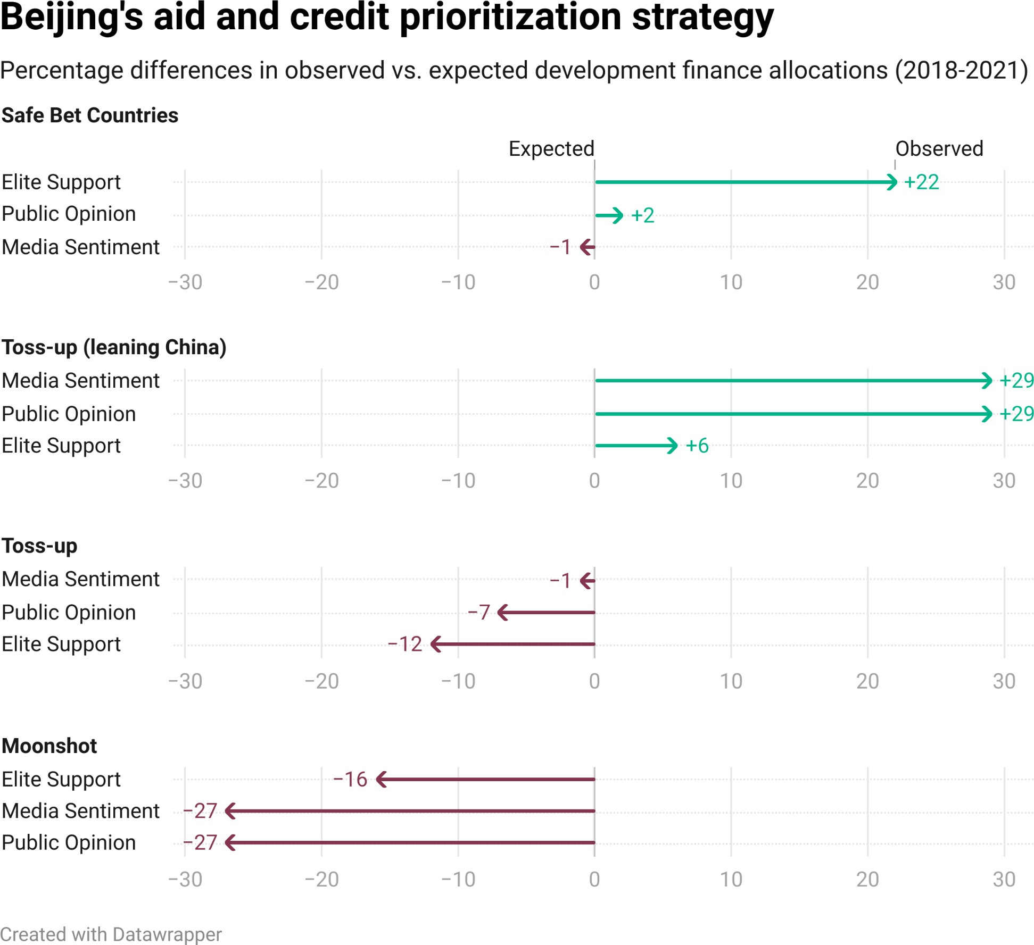

*Notes: This ﬁgure provides a visual representation of the “Difference (pp)” columns from Table 4.2 by focusing on the categories of countries which Beijing prioritized or deprioritized during the late BRI period, in apparent response to soft power gains and losses vis-à-vis the U.S. The line labeled 0 represents situations where there is no difference between the expectation and reality of Beijing's aid and credit allocation. The positive or negative values represent categories where spending exceeds and fails to meet expectations, respectively.*

Third, in the contest for international public opinion, China has shown a low tolerance level for reputational risk. During the late BRI period, it devoted two-thirds of its international development ﬁnance portfolio to toss-up countries and assigned special priority to the subset of toss-up countries that lean toward

China (see Table 4.2).[328] By contrast, it directed only 16% of its international development ﬁnance portfolio during the late BRI period to moonshot countries.[329] These resource allocation patterns suggest that China is less interested in competing in countries where its principal rival has momentum on its side and more interested in shoring up public support in countries with favorable baseline conditions. Zambia is an example of a country that Beijing showered with aid and credit when it was relatively pro-China. However, as we explain in Section 4 of this chapter, after the government defaulted on its external debt obligations in November 2020, China’s public approval rating plummeted (by -9.2 pp) and the U.S. public approval rating remained mostly unchanged (-0.3 pp). Beijing’s provision of aid and credit to Zambia all but halted, completing a dramatic full-circle turn since the heyday of Beijing’s engagement in the country during the early BRI period.

Fourth, in the quest for favorable media coverage, China strongly disfavors countries in the safe bet and moonshot categories. It devoted only 16% of its international development ﬁnance portfolio during the late BRI period to such countries. Instead, it focused 83% of its international development ﬁnance portfolio during the late BRI period on countries in the two toss-up categories. These spending patterns suggest that Beijing is neither interested in high-risk, high-reward opportunities nor low-risk, low-reward opportunities when it comes to the pursuit of favorable media coverage. Instead, it appears to be doubling down in competitive jurisdictions where it “has the wind at its back.” Figure 4.5 provides evidence of a large positive delta (+29 pp) between expected and observed Chinese development ﬁnance allocations to countries in the toss-up (leaning China) category. In the case of Bangladesh, where China experienced media sentiment gains at the expense of the U.S., average annual commitments tripled from $994 million during the early BRI period to over $3.3 billion in the late BRI period, despite challenges associated with COVID-19. In the context of growing strategic competition in the Indo-Paciﬁc, Beijing’s partnership with

Prime Minister Sheikh Hasina’s 15-year old government strengthened signiﬁcantly.[330]

Fifth, in the international contest for elite support, China shows relatively little interest in toss-up countries. Table 4.2} demonstrates that Beijing allocated only 39% of its international development ﬁnance portfolio during the late BRI period to these highly competitive jurisdictions. It directed the remaining 61% of the portfolio to countries in the moonshot category (i.e., jurisdictions where the U.S. made soft power gains at its expense) and safe bets category (i.e., jurisdictions where China made soft power gains at the expense of the U.S.).[331] These spending patterns suggest that Beijing is conﬁdent its tried-and-true strategy of trading cash for foreign policy concessions can work in any number of settings.

As we explain in Section 2, the case of Argentina is consistent with the notion that Beijing is willing to work with friendly governments, regardless of their ideological commitments or political viewpoints.

### Section 4: Country case studies

In Section 3, we learned that there is no one-size-ﬁts-all approach in China’s soft power playbook. Beijing tailors its strategy to local conditions in host countries, while accounting for recent competitive gains and losses. However, policymakers and analysts still lack a clear understanding of how China adapts its aid and credit allocation based on local contextual factors. To gain greater insight, we turn our attention to three case studies: Zambia (a toss-up country, leaning toward China during the early BRI period on the public opinion measure), Bangladesh (a toss-up country, leaning toward China during the early BRI period on the media sentiment measure), and Argentina (a safe bet country during the early BRI period on the elite support measure).[332]

#### Zambia case study: From reputational assets to reputational liabilities

In terms of public opinion changes during the early BRI period, Zambia falls into the toss-up (learning China) category of countries that moved closer to China than the U.S., but not enough to be classiﬁed as a safe bet. During the early BRI period (2014-2017), China’s average annual development commitments to Zambia jumped to $1.93 billion, as compared to only $230 million during the pre-BRI period (2000-2013). We investigate the factors that shaped China’s engagement with Zambia during the early and late BRI periods in this case study.

##### Vying for inﬂuence: The limits of Chinese soft power in Zambia

On her March 2023 trip to Zambia as U.S. Vice President (VP), where she last visited as a child to see her Indian grandfather, Kamala Harris declared her administration’s sincere and steadfast commitment to Africa. “Our presence here is not about China,” she said. “It’s about an independent understanding of the intertwined histories of our nations, and our mutual commitment to democratic principles, and a recognition and understanding of what it means to engage in smart investments and the potential for the future of the entire globe.” As proof, she announced over $7 billion in commitments from the U.S. private sector to various African countries. Most of the investments focused on advanced technologies, such as artiﬁcial intelligence (AI) for improved weather prediction, electric vehicle assembly plants, and biofertilizer facilities (White House 2023).

In the early days of the Biden administration, an effort was set in motion to launch a major counter-initiative to China’s BRI (Sanger and Landler 2021). As the White House was ironing out the details of PGII (rebranded from Build Back Better World), Africa’s lukewarm condemnation of the Russian invasion of Ukraine accelerated U.S. efforts to secure more support from African leaders. In response to a March 2022 UN General Assembly Resolution (GA/12407) that condemned Russian aggression, only 51% of African countries voted with Washington (as compared to 81% for the rest of the world). A signiﬁcant number of African countries abstained, as China did, or decided not to vote at all (White and Holtz 2022).

Keen to reset foreign relations after his predecessor's Chinese-backed infrastructure spending spree, Zambia’s Hichilema administration decided to break away from its neighbors—Zimbabwe and South Africa—and vote in favor of the UNGA resolution (Obe and Vandome 2022). Weeks later, Hichilema was rewarded with an invitation to the White House to meet VP Harris, the ﬁrst by a Zambian leader in nearly three decades. At this meeting and the December 2022 U.S.-Africa Leaders Summit, U.S. ofﬁcials did not put China on the agenda, focusing instead on messaging around their offerings to Africa. By contrast, during the previous (Trump) administration, senior ofﬁcials directly criticized China’s activities in Zambia. In December 2018, national security advisor John Bolton claimed that “China is now poised to take over Zambia’s national power and utility company in order to collect on Zambia’s ﬁnancial obligations” (Bolton 2019). A year later, speaking at a UN meeting for African leaders, Secretary Pompeo advised that “[c]ountries should be wary of authoritarian regimes and their empty promises,” because “[t]hey breed corruption, dependency and instability, not prosperity, sovereignty and progress” (Paravicini 2020).[333]

Though the Biden administration moved away from its precedessor’s rhetoric, China’s growing inﬂuence in Africa, particularly in mineral-rich regions such as Zambia’s copperbelt, remained a point of concern among U.S. government ofﬁcials, and it loomed over VP Harris’ trip. At the news conference with VP Harris in Lusaka, President Hichilema clariﬁed his position on the U.S.-China strategic competition. “When I'm in Washington, I'm not against Beijing,” he said. “And when I'm in Beijing, I'm not against Washington” (White House 2023). Soon after his August 2021 landslide victory over incumbent Zambian President Edgar Lungu, Hichilema struck a cordial tone with both powers, seeking improved ties with each (Obe and Vandome 2022). But he later discovered—during months of contentious restructuring negotiations with creditors from the Paris Club, China, and private bondholders following the country’s November 2020 sovereign default—that resolving Zambia’s debt issues would require delicate management of U.S.-China tensions.

From a soft power perspective, Beijing encountered the limitations of its state-led overseas development ﬁnancing model before Hichilema came to power. Despite warnings from the International Monetary Fund that “the pace of borrowing needs to be slowed down signiﬁcantly,” the Patriotic Front (PF) presidencies of Michael Sata and Edward Lungu oversaw a period of “proﬂigacy and theft of the ruling elite” that increased public debt from 32% of GDP in 2012 to 120% by 2020 (The Economist 2020). Chinese state-owned creditors played a major role in bankrolling the country’s borrowing binge for big-ticket infrastructure projects. From 2000 to 2011, China’s average annual lending commitments to Zambia amounted to only $178.3 million. However, between 2012 and 2018 (during the Sata and Lungu administrations), its average annual lending commitments soared to $932 million.

Efforts to construct, expand, and rehabilitate large-scale infrastructure—including roads, airports, power plants, transmission lines, and water and sanitation systems—with Chinese credit continued until late 2018, when the country’s debt-to-GDP ratio surpassed 90%. This development triggered alarm around the world and particularly in Beijing because of its high level of exposure to non-performing loans. China also witnessed a sharp decline in its public approval rating once it turned off the credit tap: whereas 79.5% of Zambians approved of the Chinese government in 2017, this ﬁgure dropped by

12.9 percentage points (to 66.6%) in 2021.[3][3][4]

Therefore, an important lesson from this case study is that Beijing’s strategy of buying soft power through the supply of credit-driven development projects has limitations. This is likely true of any BRI participant country, but the risks are especially high in poorly-governed countries with long histories of corruption and ﬁnancial mismanagement. Beijing’s experience in Zambia also calls attention to the fact that its rivals are well-positioned to make inroads with governing elites and the general public in such countries.

##### Why is Zambia relevant to great power competition?

China’s development ﬁnance portfolio in Zambia is among its most well-known globally, due to the country’s widely-reported debt crisis. But there is much more to the story of China in Zambia than the latter’s debt repayment struggles. With the world’s 7th largest copper reserve, a mineral that is needed for advanced technologies to fuel the green energy transition, Zambia is a high-value target in the great power competition between China and the U.S. (S&P Global 2022).

Within years of declaring independence from Britain, Zambia became home to China’s ﬁrst-ever foreign assistance megaproject, the iconic TAZARA Railway that links Zambia’s copperbelt heartland to Tanzania’s port of Dar es Salaam (Dreher et al. 2022). Today, China is Zambia’s largest trading partner, responsible for buying over 75% of its main export, copper (The Growth Lab at Harvard University 2023). China is also one of Zambia’s largest foreign creditors and donors. Between 2000 and 2021, it issued grants and loans to Zambia worth $13.7 billion. Beijing ﬁnanced $10.03 billion in infrastructure projects during the BRI era (2014-2021), including major intercity and urban highways, hydropower stations and accompanying transmission lines, international airports, communications systems, hospitals, universities, coal-ﬁred power plants, and water supply systems.[335]

**Figure 4.6**

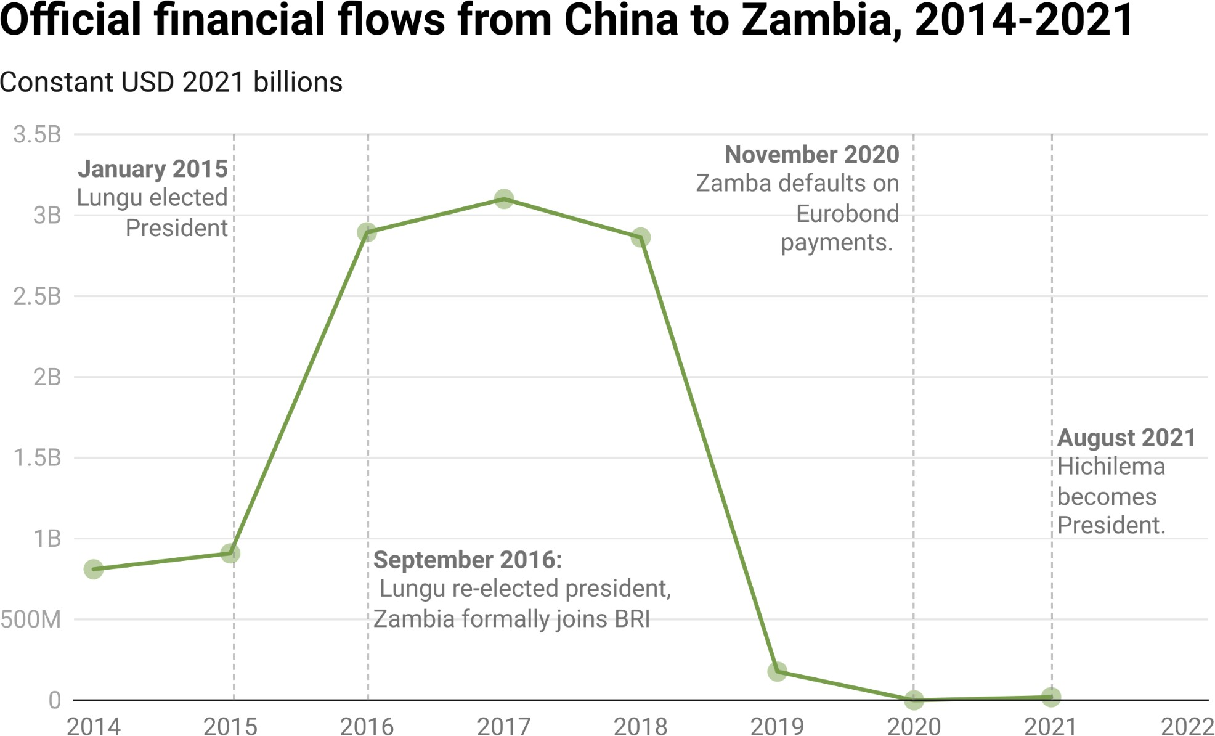

*Notes: AidData relies on OECD-DAC measurement criteria to make ODA and OOF determinations (as described in Section A-2 of the Appendix).*

**Figure 4.7**

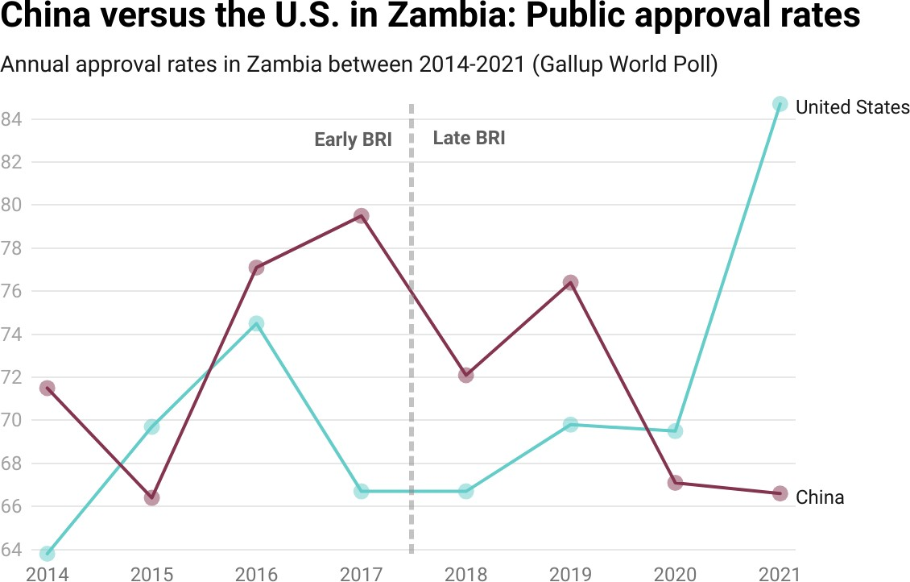

Given China’s extensive engagements with Zambia for more than seven decades, it is not surprising that 72% of Zambians approved of the Chinese government during the BRI era (see Figure 4.7 above). However, Beijing enjoyed only a two percentage point advantage over its primary competitor (Washington) during this period, despite the fact that Chinese development ﬁnance commitments ($17.47 billion) dwarfed U.S. development ﬁnance commitments ($3.40 billion). During the BRI era, U.S. development ﬁnance remained relatively stable[336]—both in volume and composition—but Washington saw its public approval rating in Zambia soar throughout early and late BRI periods, from 63.8% in 2014 to 84.7% in 2021 (see Figure 4.7}).[337] China, on the other hand, saw its public approval rating steadily decline during the late BRI period.

Supplementary data from Afrobarometer suggest that, during the late BRI period, Zambians re-evaluated the wisdom of following China’s state-centric and infrastructure-focused development model as an alternative to the West’s rights, freedoms, and market institutions-based approach. When Afrobarometer surveyed Zambians in 2014-2015 about the country they considered to be the “best model for development,” 32% chose China and 23% picked the U.S. However, by 2019-2021, when the link between poorly-executed Chinese megaprojects and Zambians’ economic woes had been laid bare, Beijing’s nine-point advantage had ﬂipped in favor of Washington, with only 22% respondents expressing a preference for China’s model and 31% choosing the

U.S. model. This represented a reversal of fortune for China at the end of its decade-long partnership with the ruling party (the Patriotic Fund, or PF) , which started with President Sata’s May 2013 Beijing visit.

##### The Patriotic Fund’s infrastructure binge

The PF’s relationship with Beijing began in outright hostility during the unsuccessful 2006 presidential campaign of a ﬁery former trade unionist, Michael Sata, whose abrasive politics earned him the nickname “King Cobra” (Kimenyi and Copley 2014). By orienting his campaign around a new agenda of Sino-skepticism, he rallied support against the 15-year rule of the Movement for Multi-Party Democracy (MMD), arguing that Chinese investors were “coming just to invade and exploit Africa” (French 2011). At one point, he even suggested that, if elected, he would recognize the Republic of China (Taiwan) as a “sovereign state” (Mupuchi 2006). China’s Ambassador in Lusaka responded by threatening that Chinese investment would be “put on hold [...] until the uncertainty surrounding our bilateral relationship with Zambia is cleared”—that is, until Sata’s electoral loss was conﬁrmed (Shacinda 2006). After two unsuccessful presidential bids, Sata relaxed his rhetoric during a successful 2011 presidential campaign by stating his appreciation for the beneﬁts of Chinese investment in Zambia while insisting that foreign mining companies abide by local laws to protect workers (Mfula 2011; Shukla 2021).

Sata’s April 2013 visit to China reset Sino-Zambian relations. According to the

3.0 version of AidData’s GCDF dataset, Beijing issued grant and loan commitments worth $810.2 million for nine new projects in 2013. In the same year, it started delivering ﬁve additional projects worth $111.6 million, and it completed delivery of a $7.4-million equipment supply project for the upkeep of the TAZARA railway. Unlike the MMD-era, when China’s largest ﬁnancial commitments were earmarked for sports stadiums, the focus shifted toward infrastructure projects ostensibly designed to generate economic growth. This type of engagement continued until Sata’s death in October 2014. Over the course of the Sata presidency, Beijing issued grant and loan commitments worth $1.6 billion for high-proﬁle projects, including upgrades to the Lusaka airport, improvements to the Lusiwasi hydroelectric power plant, the construction of new power transmission lines, and road rehabilitation activities. For a country where less than half the population has electricity access and paved road density is among the world’s lowest, China’s willingness to bankroll infrastructure projects with signiﬁcant economic growth potential was a welcome departure from the OECD-DAC’s emphasis on health, education, and governance projects.[338]

After Sata’s death, his Minister of Justice and Defence Edward Lungu won a highly contested election in January 2015 to complete the remainder of his term. Anticipating an election the following year, Lungu visited China in March 2015 to accelerate the momentum behind new infrastructure projects. In the run up to Lungu’s August 2016 re-election, Chinese grant and loan commitments tripled from $910 million in 2015 to $2.9 billion in 2016. As in prior years, the bulk of the money supported physical infrastructure, including more airports, roads, and water supply systems. However, this time around, China also committed $468 million for ICT (information and communications technology) sector activities, including the installation of CCTV cameras and smart city projects. These types of “AI-enabling” tools are reserved for Beijing’s closest allies, especially in countries where political systems are turning more authoritarian, such as in Kenya and Pakistan where they have been deployed against political opponents (Bouey et al. forthcoming).

Beijing doubled down on its support for Zambia during the Lungu administration—perhaps because it thought that a stable and pro-China government could serve as a de facto insurer for its project and investments. China’s popularity soared during this period. Public approval for China, as measured by the Gallup World Poll, rose from 66.4% in 2015 to its highest ever level of 79.5% in 2017.

After narrowly winning re-election with 50.4% of the vote in August 2016, Lungu was quick to announce that “President Xi Jinping has expressed conﬁdence in my leadership.” He reiterated his resolve to further deepen his engagements with China to “empower businessmen and beneﬁt every Zambian” (Shaban 2016). In the following year, Chinese grant and loan commitments amounted to $3.1 billion, half of which was a loan for the 750 MW Kafue Gorge hydropower project.

Then, in September 2018, Lungu visited China to attend the Forum on China-Africa Cooperation (FOCAC) summit where he formally signed up his country to participate in the BRI. Beijing responded by providing an additional $2.9 billion of aid and credit for roads ($1.4 billion), power transmission lines ($499 million), cement plants ($445 million), public housing ($229 million), and university construction ($208 million).[339]

##### When reputational assets become liabilities

As Chinese state-owned entities lent record amounts to Zambia, the IMF sounded the alarm about the composition and sustainability of Zambia’s external debt burden (International Monetary Fund 2017). Between 2011 and 2016, public and publicly guaranteed (PPG) external debt skyrocketed from 8.4% of GDP to 36.5%. The share of central government debt owed to private creditors—which was provided on mostly non-concessional terms—increased to 50%. The share of central government debt owed to MDBs—which was provided on mostly concessional terms—shrank from 60% to 20.5%. The IMF warned that the “pace of borrowing needs to be slowed signiﬁcantly” to align with the country’s “absorptive capacity” through more stringent standards for “the selection, procurement, and monitoring of infrastructure projects.” (International Monetary Fund 2017). Despite these warnings and Zambia’s past experiences with debt distress, the Zambian government and its external creditors failed to pump the brakes (International Monetary Fund 2023).

Reports emerged that Zambian government agencies pressured the Ministry of Finance to sign-off on politically advantageous but commercially non-viable projects (Mutati 2016). In one instance, a senior government ofﬁcial dealing with the Mbala-Nakonde road alleged that “the [Chinese] contractor had already secured the agreement with the Ministry of Finance when they came to us. We just negotiated about the details of design, not the amount of the loan” (Lee 2018). Zambia’s rush to launch as many high visibility projects as possible was a function of political economy considerations. Thin electoral victory margins in the country’s presidential elections “create powerful incentives to use public works to reward constituencies” (Brautigam 2021).

A review of China’s ODA and OOF portfolio in Zambia reveals that 19 out of 21 projects identiﬁed as having ESG challenges faced governance-related concerns, such as overpricing, corruption, and ﬁnancial mismanagement (see Table A12).[340] In July 2019, then-opposition leader and future president Hakainde Hichilma claimed that “the debt that was acquired for just one project, Lusaka-Ndola (Dual Carriageway) road, which should cost US$400 million[...] is costing US$1.2 billion.” He argued that Zambians “are giving [projects] to China in the corrupt way, which is costing us too much of taxpayers’ money” (Ncube 2019).[341] In 2022, Dr. Mbita Chitala, the former chairman of the Board of Directors of ZESCO (Zambia’s state-owned power utility), published a book entitled Corporate Capture: The Political Economy of Electricity Management in Zambia 2014-2021 (How Not to Manage a State Enterprise). In it, he claimed that large segments of the China Eximbank-ﬁnanced Smart Zambia National ICT Development Project were completely unnecessary and designed to enrich senior government ofﬁcials. He recalled that “the whole project was a conspiracy to defraud Zambia” because Huawei was proposing solutions that were “inferior to ZESCO existing network” and located in towns that were already served (Chitala 2022).[342]

By late 2018, the Zambian government was cash-strapped and Beijing’s development project portfolio began to suffer. The Zambian government was increasingly unable to meet its ﬁnancial commitments to Chinese contractors and creditors. For example, after CDB issued a $469-million loan in December 2015, the Copperbelt Urban Roads Project faced a series of implementation delays until the state-owned engineering, procurement, and construction (EPC) contractor, China Henan International Cooperation Group Company (CHICO), abandoned the project due to insufﬁcient payments by the Zambian government. The 750 MW Kafue Gorge hydropower project, the country’s single largest energy sector project, faced severe implementation challenges when the borrower—a wholly state-owned special purpose vehicle known as Kafue Gorge Lower Power Development Corporation Limited—defaulted on its loan repayment obligations to ICBC and China Eximbank.[343] In both cases, senior government ofﬁcials claimed that Lusaka would come up with the cash needed to complete the projects. The 750 MW Kafue Gorge hydropower project was not completed until April 2023—approximately 13 years after Sinohydro, the EPC contractor, signed an MOU to complete the project on a build-operate-transfer basis. The Copperbelt Urban Roads Project was indeﬁnitely suspended. The Lusaka-Ndola (Dual Carriageway) Road Project suffered a similar fate.

Between 2019 and 2021, new grant and loan commitments from China were virtually non-existent. After providing average commitments worth $3 billion between 2016 and 2018, Beijing sharply reduced its average annual commitments to $66 million from 2019 to 2021. If China’s bid to accumulate soft power requires demonstrating that its economic development model is effective and sustainable, Zambia represents a spectacular failure. Projects that were supposed to be reputational assets—and spur Chinese-led economic growth for Zambians—became reputational liabilities.

##### The limitations of infrastructure ﬁnancing for soft power accumulation

The Zambian case illustrates the limitations of China’s strategy of using large-scale infrastructure projects to expand its inﬂuence overseas. This outcome was not completely of China’s making. Nor was it inevitable. Rather, it was due to overborrowing for projects whose feasibility was based on either optimistic or “graft ridden” projections (The Economist 2018). For instance, the new terminal at Lusaka’s Kenneth Kaunda Airport was designed to accommodate “an improbable ten-fold increase in passenger trafﬁc,” and at $360,000 per kilometer, the average price tag of roads built between 2011 and 2018 was “more than twice the African average” (The Economist 2018). Had the Zambian government or Chinese creditors followed more robust due diligence requirements (see relevant discussion in Chapters 2 and 3), these pitfalls could have been minimized or otherwise avoided. However, these factors ultimately led to the downfall of the entire model, resulting in massive losses for the Lungu administration, China’s reputation, and above all else, the people of Zambia.

Going forward, Beijing might be able to reverse the reputational losses that it has suffered if it follows through on a June 2023 debt relief commitment and if local economic conditions improve. In addition, several previously stalled infrastructure projects—those that were delayed due to COVID-19 and ﬁnancial distress—will soon reach completion and potentially increase public support for

China. Beijing could also consider sending high-ranking CPC ofﬁcials or even organize a state visit by President Xi to reset and deepen ties with Lusaka.

However, as compared to his predecessor, President Hichilema appears to be playing a careful balancing act in his relations with China and the U.S., and he will likely tread carefully.

#### Bangladesh case study: Stability in authoritarianism

Bangladesh, like Zambia, is a competitive jurisdiction that we classiﬁed as a toss-up (leaning China) country. During the early BRI period, China made modest media sentiment gains there at the expense of the U.S. It also dramatically increased the provision of aid and credit to Bangladesh during the late BRI period. Whereas average annual ODA and OOF commitments from

China to Bangladesh were only $994 million between 2014 and 2017, this ﬁgure soared to $3.4 billion between 2018 and 2021. This unprecedented spending increase coincided with a period of political stability, particularly after Prime Minister Sheikh Hasina won her second consecutive electoral victory in 2018. It also coincided with a period of rising authoritarianism.

##### China’s late BRI era foray into Bangladesh

In May 2021, Chinese Ambassador Li Jiming issued a stern warning to Bangladesh’s elites. In response to reports that Dhaka might join the Quadrilateral Security Dialogue (the Quad)—an informal coalition between the U.S., Japan, Australia, and India—he said that such a move would inﬂict “substantial damage” on Sino-Bangla relations. This uncharacteristically blunt remark provoked strong pushback from Bangladesh’s Foreign Minister A.K. Abdul Momen. “We are an independent and sovereign state. We decide our foreign policy,” he said. He also clariﬁed that Dhaka was neither approached by the members of the Quad nor was its participation in the Quad a possibility under active consideration (Islam 2021).

This diplomatic spat highlights Bangladesh’s desire to delicately balance relations with the U.S. and its closest regional partner (India), while bolstering its “strategic partnership” with China (Ministry of Foreign Affairs of the People’s Republic of China 2016). Bangladesh is located in the strategically vital

Indo-Paciﬁc region, serving as a gateway between South Asia and Southeast Asia. For China, it is an entry point to the Bay of Bengal, and its proximity to Myanmar increases its strategic value to the U.S. and its Quad allies.

Since Prime Minister Sheikh Hasina’s assumption of power in 2009, Bangladesh has made tremendous economic and social development progress: extreme poverty has been reduced by half; life expectancy has risen by 6 years; the average economic growth rate has exceeded 7%; and per capita income has risen by 3.5 times (United Nations 2022; Trotsenburg 2023). At the same time, Sheikh Hasina has effectively turned Bangladesh into a single-party system, ushering in a period of authoritarianism.[344] Between 2009 and 2022, the country’s position on the Reporters Without Borders’ Media Freedom Index fell from 121 to 162 out of 180 countries (Reporters Without Borders 2023). Its overall performance on Freedom House’s Freedom in the World Index tumbled by a quarter, with political rights eroding by nearly one-third (Freedom House 2022, 2023).

For the U.S. and its allies, Bangladesh’s positive economic development trajectory, democratic backsliding, and geostrategic position presents a policy conundrum. Bangladesh’s concentration of power in one person, lack of tolerance for political dissent, and singular focus on infrastructure-driven, export-led economic growth is strikingly similar to Beijing’s own. Yet, the Quad is seeking to expand its footprint in the Indo-Paciﬁc and has reportedly reached out to Bangladesh about the possibility of a regional “economic partnership” (Kishida 2023).

Beijing is evidently aware that Bangladesh is a competitive jurisdiction where it cannot afford to rest on its laurels. In a recently published op-ed, the Chinese Ambassador to Bangladesh announced that “China is set to bring more development opportunities to Bangladesh,” predicting that the country’s exports to China would grow signiﬁcantly after Beijing announced duty-free market access to most Bangladeshi products (Wen 2023). In other statements, he has accused the U.S. of pressuring Dhaka to deviate from its longstanding position of neutrality in great power competitions. In April 2023, the Bangladeshi Ministry of Foreign Affairs released its ﬁrst-ever “Indo-Paciﬁc Outlook,” restating the “political dictum” of the country’s founding father Sheikh

Mujib ur Rehman (‘Friendship toward all, malice toward none”) as a guiding principle (Ministry of Foreign Affairs of Bangladesh 2023).

As we previously noted, Bangladesh was selected as a case study country because it fell in the toss-up (leaning China) category during the early BRI period (according to the media sentiment analysis described in Section 2). However, on multiple dimensions of soft power, Bangladesh remains a toss-up country, leaning toward neither China nor the U.S.. Both powers—as well as India—are actively vying for inﬂuence there (Asmus et al. forthcoming). Beijing has responded to its recent soft power gains in Bangladesh by doubling down on the provision of aid and credit. This outcome was likely made possible by several factors related to Bangladesh’s domestic political and economic environment: a dominant single party government in-charge of a centralized governance system, a strong focus on rapid delivery of highly visible physical infrastructure projects, and proactive debt management.

##### Sheikh Hasina’s rise and the end of political instability

Within months of independence from Pakistan in 1971, the ruling Awami League (AL) party started moving Bangladesh’s nascent political system toward a single-party system. But a combination of factors—including economic mismanagement, rising political repression, and growing concern about the country’s future—led to multiple military coups and dictatorships from 1975 to 1990 (Riaz 2016). After a return to democracy, the period from 1991 to 2008 was marred by political crises, dysfunctional governance, and frequent violent clashes between supporters of Sheikh Hasina’s AL and Khaleda Zia’s Bangladesh Nationalist Party (BNP) (Mannan 2018).

A key source of inﬁghting was the bitter history of animosity between the two leaders, originating in the 1975 coup d’etat against the government of Sheikh Hasina’s father, Sheikh Mujib ur Rehman (the country’s founder). Military ofﬁcers not only assassinated Sheikh Mujib, but also all three of Sheikh Hasina’s brothers, two of her sisters-in-law, and her mother. After the coup, Khaleda Zia’s husband General Zia ur Rahman emerged as a key military and political leader, eventually becoming president two years later and forming the BNP, which he led until his assassination in 1981. The tremors from these events still reverberate in Bangladesh’s politics, as AL seeks to fulﬁll Sheikh Mujib’s desire to run the country as a single-party democracy.

Between 1991 and 2006, Zia served two terms in ofﬁce and Hasina served one term in ofﬁce. This era represented an electorally competitive period, albeit one marked by frequent political and constitutional crises (Vaughn 2008). Then, prior to the elections scheduled for early 2007, the military intervened and appointed a technocratic interim government to oversee fresh elections. These were eventually held in December 2008, leading to Sheikh Hasina’s AL return to power, which she has held onto ever since. She has steadily solidiﬁed her grip on the political system, stiﬂing opposition forces and retaining power through heavy-handed authoritarian measures to control the media and judiciary (The Economist 2023).

##### The soft power beneﬁts of development ﬁnance

Between March 1971 (when the country gained its independence) and December 2008, Bangladesh’s largest foreign aid and credit providers were Japan, the U.S., and the U.K. China did not maintain an especially large development ﬁnance program during this period. However, during the BRI era, Beijing issued grant and loan commitments worth $17.5 billion, making it Dhaka’s single largest development partner. In 2006, China also surpassed India and the U.S. to become Bangladesh’s largest trading partner, with $4.7 billion in total ﬂows. One might assume that the combination of high trade volumes and unprecedented levels of aid and credit for highly visible infrastructure projects led to rapid soft power accumulation for China. However, in reality, the relationship between development ﬁnance and soft power has not been straightforward for several reasons.

**Figure 4.8**

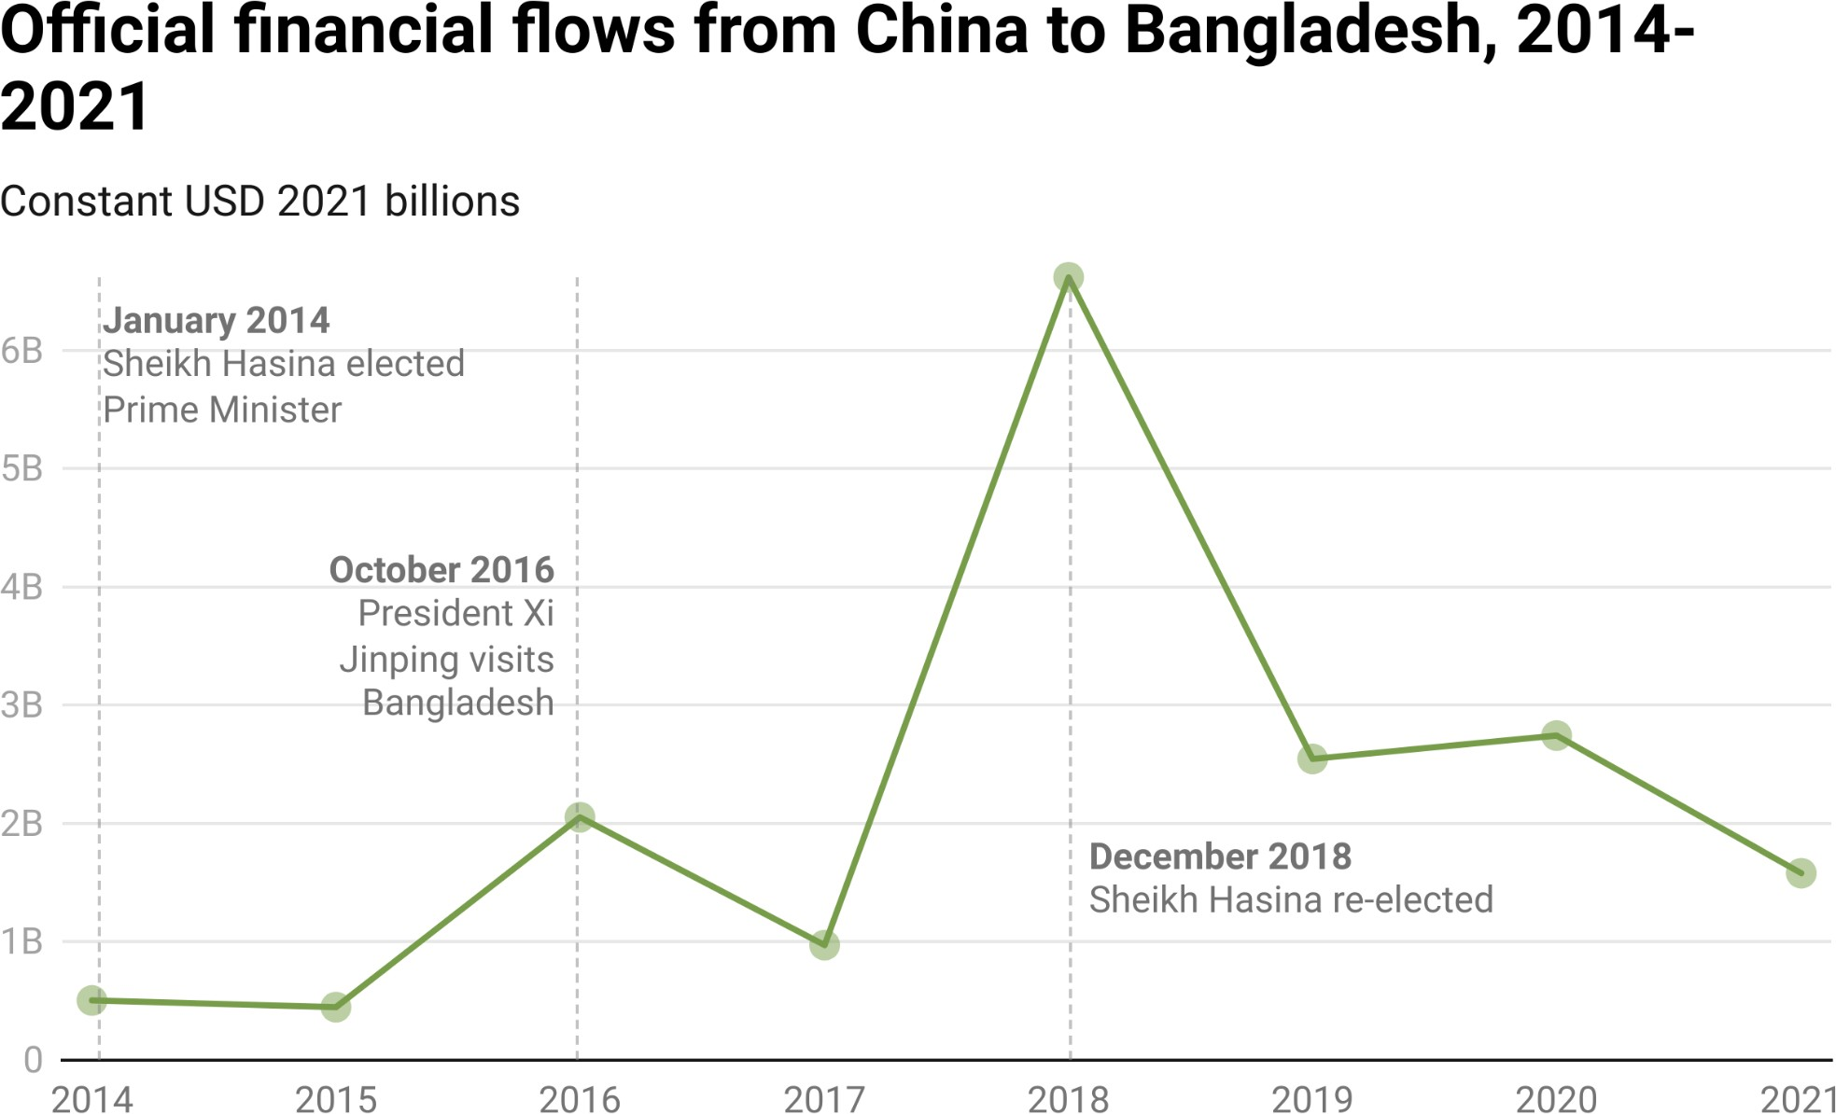

*Notes: AidData relies on OECD-DAC measurement criteria to make ODA and OOF determinations (as described in Section A-2 of the Appendix).*

According to the 3.0 version of AidData’s GCDF dataset, China issued grant and loan commitments worth $20.8 billion for 138 projects in Bangladesh between 2000 and 2021 (see Figure 4.8).[345] That made Bangladesh one of China’s 20 largest aid and credit recipients in the developing world and its 7th largest recipient in Asia. China’s ODA and OOF commitments to the country soared from $3.3 billion during the pre-BRI period (2000-2013) to $17.5 billion during the early and late BRI period (2014-2021). During the BRI era, the project portfolio was largely focused on the construction and rehabilitation of power plants, transmission lines, highways, and bridges.

**Figure 4.9**

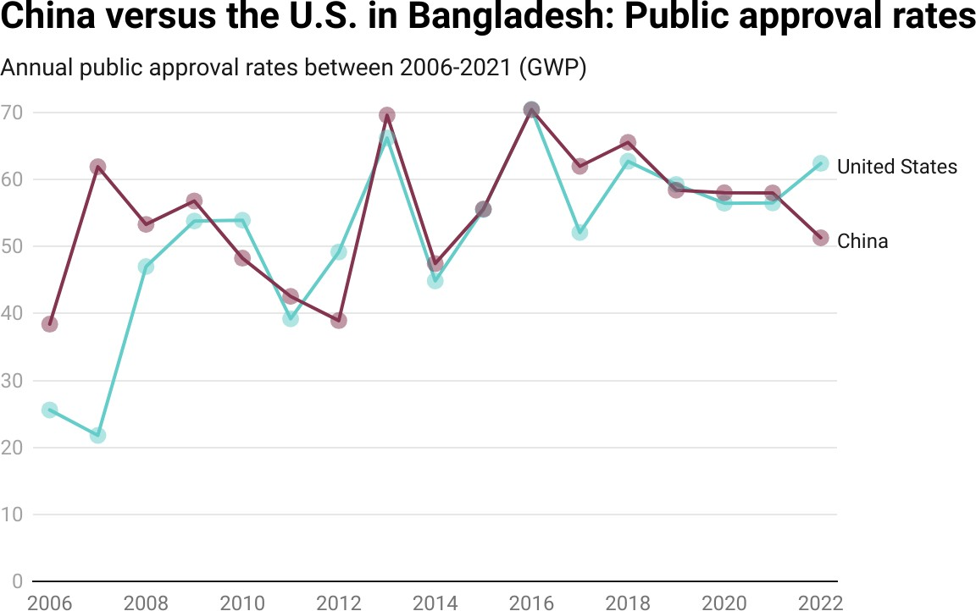

Given the unprecedented scale of these ﬁnancial commitments and the highly visible nature of the infrastructure projects undertaken during the BRI era, it is not surprising that Beijing has made some public opinion and media sentiment gains since 2014. The average level of public approval for the Chinese government was 49% between 2006 and 2013 (see Figure 4.9). Then, during Sheikh Hasina’s second and third consecutive terms in ofﬁce (from 2014 to 2018 and from 2019 to 2022), Beijing saw its average public approval rating increase to 60% and 56%, respectively.

The U.S. and China generally enjoyed similar levels of public support in Bangladesh during the BRI era (see Figure 4.9). However, shortly after Donald Trump came to power, the U.S. suffered an 18 percentage point decline in its public approval rating (from 70% in 2016 to 52% in 2017), which gave China a 10% percentage point advantage over the U.S. in 2017. Beijing’s advantage was nevertheless short-lived. By 2022, Washington saw its public approval rating rise to 62%, thereby opening up an 11 percentage point advantage over Beijing in 2022.

**Figure 4.10**

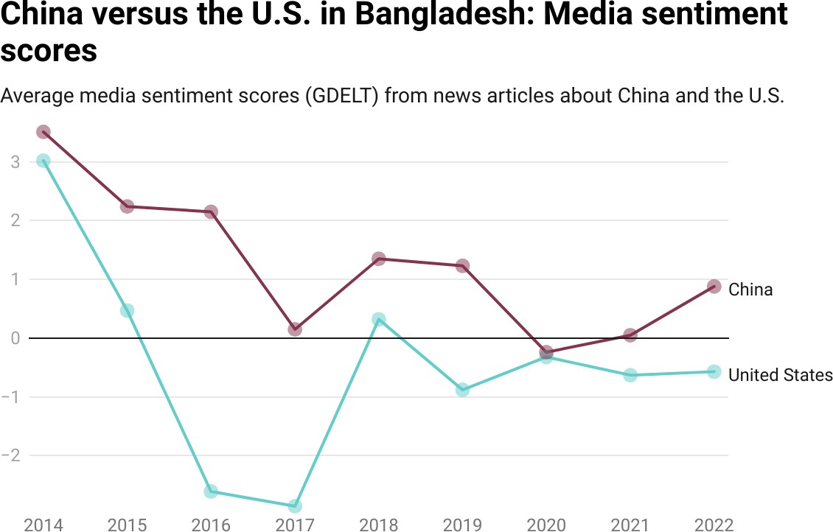

*Notes: The data are drawn and processed from the GDELT 1.0 Event Database (related to government actors from mainland China or the U.S.). See Box 1b in Chapter 1 for more details.*

In terms of the competition for favorable media coverage, the GDELT data indicate that, during Sheikh Hasina’s 2014-2018 term, the average tone of media sentiment about China (+1.88) was signiﬁcantly more positive than the average tone of media sentiment (-0.33) about the U.S. (see Figure 4.10). However, between 2019 and 2022, China’s average media sentiment score declined to

+0.48.[346] One potential reason why media coverage about China may have become less favorable during the late BRI period is that $10 billion (or nearly 38%) of Beijing’s development ﬁnance portfolio in Bangladesh encountered signiﬁcant ESG problems (see Table A12), including social and governance challenges associated with the design and implementation of multiple coal-ﬁred power generation plants.[347] The U.S. also saw its average media sentiment score deteriorate (to -0.6) during the 2019-2022 period, though the decline that it experienced was smaller than the one experienced by China. As a result, the media sentiment gains that Beijing made at the expense of Washington during the early BRI period were partially reversed during the late BRI period (see Figure 4.10).

##### The foundations of Beijing’s partnership with Sheikh Hasina

The rapid rise of Chinese development ﬁnance during the BRI era was facilitated by Beijing’s strong partnership with Sheikh Hasina’s AL government, which grew as she strengthened her grip on power. Since December 2008, the centralization of political power has resulted in higher levels of administrative certainty and created an enabling environment for Beijing to bankroll and build big-ticket infrastructure projects.

**Table 4.3**

## Development ﬁnance commitments from China to Bangladesh by executive administration ﬁnance (ODA and OOF) from China during each administration

**ODA % from China**

Ahmed (2007-2008)

|  |  |
| --- | --- |
| **(USD 2021 millions)** |  |
| BNP’s Khaleda Zia (2002 - 2006) 175 | 72% |
| Military-appointed Fakhruddin 71 | 100% |
| Sheikh Hasina I (2009-2013) 381 | 47% |
| Sheikh Hasina II 2,191 | 20% |
| Sheikh Hasina III 2,290 | 7% |

*Notes: This ﬁgure provides a summary of Chinese ODA and OOF commitments to Bangladesh during each executive administration in Bangladesh since 2002. Exact commitment dates in the 3.0 version of AidData’s*

*GCDF 3.0 were compared to election dates and political transition dates to categorize each ODA/OOF-ﬁnanced project according to the chief executive that was in power at the time of the commitment. “ODA % from China” displays the proportion of China’s development portfolio that is classiﬁed as ODA and that was committed during each executive administration. AidData relies on*

*OECD-DAC measurement criteria to make ODA and OOF determinations (as described in Section A-2 of the Appendix).*

As Table 4.3 demonstrates, the volume and composition of Chinese development ﬁnance in Bangladesh have changed signiﬁcantly over the course of the last ﬁve administrations. Financial commitment amounts have soared since the military-backed interim government of 2007-2008, but the proportion of Chinese development ﬁnance provided via ODA (grants and highly concessional loans) has fallen sharply, which reﬂects Beijing’s growing focus on larger-scale, revenue-generating projects, such as power plants and tolled bridges.

Between 2000 and 2008, under the government of Bangladesh National Party (BNP) leader Khaleda Zia and the military-backed technocratic government of Fakhruddin Ahmed, average annual Chinese development ﬁnance commitments amounted to only $175 million and $71 million, respectively (see Table 4.3).

During this period, 82% of total commitments, or $1.2 billion, supported just seven large projects, including a transmission line, fertilizer plant, and bridge. Beijing also supported smaller projects to promote public goodwill, such as cycle relief activities, scholarships to study in China, and the China-Bangladesh convention center as a monument of friendship.

The nature of Beijing’s engagement in Bangladesh began to shift during the late years of Sheikh Hasina’s second term (2009-2013), with average annual commitments ($381 million) more than doubling those issued to the two previous two governments (see Table 4.3). With a greater focus on “bankable” infrastructure, the share of Chinese development ﬁnance provided via ODA dropped to 47%. Project sizes also increased. Beijing issued loans worth $697 million for a fertilizer factory and $595 million for 3G mobile and national internet broadband network upgrades, power plants, and an urban water treatment plant.

But the most dramatic changes took place after Sheikh Hasina’s 2013 visit to Beijing, at which time a major new focus on power generation and transport connectivity was agreed upon at the highest levels. With greater political stability and conﬁdence in her political longevity, Beijing agreed to green-light a set of transformative investments that could help Sheikh Hasina meet the ambitious goals she set for export-led economic growth as a means of lifting millions out of poverty. China’s own development model aligned with her vision, which may explain why its average annual development ﬁnance commitment grew by a factor of seven (to $2.2 billion) between 2014 and 2018 (see Table 4.3).

The conventional wisdom is that China dramatically scaled back its overseas lending commitments during the late BRI period due to the COVID-19 pandemic and rising concerns about debt sustainability (see Chapter 2).

However, Beijing behavior in Bangladesh belies this claim. On average, between 2019 and 2021, Sheikh Hasina’s government accepted $2.3 billion per year in new ODA and OOF commitments from China, which enabled the rapid progress (or completion) of high-proﬁle projects such as the Padma Bridge, the Dhaka elevated expressway, and several power plants (see Table 4.3 and Table 4.4).

From Sheikh Hasina’s perspective, these are arguably the most politically advantageous undertakings supported by China: Padma Bridge sits within her home district and political constituency; the Dhaka expressway improves urban mobility for the country’s political and business elite; and new power plants could eliminate crippling power shortages affecting all Bangladeshis.[348]

##### The best of all worlds: Single-party governance, proactive debt management, and insatiable infrastructure demand

Despite widespread international condemnation of growing authoritarianism and alleged human rights abuses during her 15-year term in ofﬁce, Asia’s “iron lady” is poised to fulﬁll her late father’s vision of turning Bangladesh into a one-party state (The Economist 2023). During recent media interactions, Sheikh Hasina has claimed that her AL party is the only legitimate political force in the country that should be allowed to contest elections because the main opposition BNP was created by erstwhile military dictators. Her critics argue that, under her watch, Bangladesh’s economic progress has become solely reliant on nepotistic textile industrialists, and her team is out of fresh ideas to tackle deep rooted structural problems, such as corruption.[349] Irrespective of these challenges, with major opposition parties in disarray and dissenting voices in civil society largely silent, today she is predicted to win the January 2024 election.[350]

**Table 4.4**

## Chinese ODA and OOF infrastructure project milestones during the second half of 2018 in Bangladesh (USD 2021 millions)

*Notes: This table identiﬁes Chinese ODA- and OOF-ﬁnanced infrastructure project milestones in the*

*6-month period preceding the December 2018 national elections in Bangladesh. The ﬁnancial commitment amounts only represent those from ofﬁcial sector institutions in China. AidData relies on OECD-DAC measurement criteria to make ODA and OOF determinations (as described in Section A-2 of the Appendix).*

Previous research has demonstrated that elections provide powerful incentives for politicians to showcase their performance, and highly visible physical infrastructure projects are ideal for achieving this goal (Marx 2018; Anaxagorou et al. 2020). In Zambia, Brautigam (2022) argues that the competitiveness of presidential elections heightens this desire, but in Bangladesh the stakes appear to be high even in relatively uncompetitive elections, such as in 2018 when the main opposition party BNP boycotted them. In the run-up to the December 2018 election, Beijing also seemed to make special efforts to ensure that its favored candidate, Sheikh Hasina, was in the best possible position to win reelection.[351]

In the six-month period leading up to the December 2018 election, Beijing approved, started implementation on, or completed projects backed by grant and loan commitments worth $6.8 billion (see Table 4.4). One of these projects included the 1,320 MW Banskhali coal-ﬁred power plant, which was ﬁnanced by ﬁve Chinese creditors (Agricultural Bank of China, China Development Bank, China Construction Bank, and Bank of China, China Minsheng Bank) and one local creditor (Rupali Bank Limited) through a $1.78 billion syndicated loan.

During the same six-month period, Chinese state-owned companies began the implementation of six additional projects backed by ﬁnancial commitments worth $6.5 billion, including the 1,320 MW Payra coal-ﬁred power plant and the high-proﬁle Padma bridge rail link project. Beijing kept up the momentum after Sheikh Hasina won re-election. During the ﬁrst six months of her new term in ofﬁce, Chinese donors and lenders green-lit new projects worth $1 billion; Chinese ﬁrms started implementing new projects backed by ofﬁcial ﬁnancial commitments worth $1.2 billion; and two projects (backed by Chinese loans worth $300 million) were completed (see Table 4.4). As in prior years, the projects were infrastructural in nature (for electricity production and national internet connectivity).

Similar to its relationship with Edward Lungu in Zambia and the Kirchners in Argentina, Beijing’s partnership with Sheikh Hasina appears to reﬂect a preference for working with incumbents who have good reelection prospects—or political longevity for other reasons. From a return-on-investment standpoint, this preference may reﬂect the fact that Chinese infrastructure ﬁnanciers want their loans repaid on time and with interest.[352] However, given that infrastructure project completion increases public support for China (Wellner et al. forthcoming 2023), Beijing’s diplomats likely also have incentives to prioritize collaboration with stable governments that have put in place policies and institutions which facilitate the delivery of large-scale infrastructure projects.[353]

##### The gateway to South and Southeast Asia

Given its unique locational position and recent geopolitical trends—including the rise of India and growing Sino-U.S. tensions in the South China Sea—Bangladesh will likely remain a key battleground for great power competition in the coming years. From Dhaka’s vantage point, growing competition between China and the U.S. in the Indo-Paciﬁc region only offers more opportunities for improving economic growth. Its economy still needs diversiﬁcation—e.g., through new competitive industries adjacent to its dominant textile industry. This will require investment, skills transfer, and further integration of existing industries into global supply chains. A deepening trade relationship with China, potentially through the planned rail link via Myanmar, could increase economic prosperity through job creation.

From the U.S. perspective, its robust trade ties with Bangladesh and strong alliance with India (Bangladesh’s most inﬂuential regional partner) may provide opportunities to make inroads. Yet recent events—including vote rigging, voter intimidation, the use of violence, and the targeting of Nobel Peace Prize laureate Muhammad Yunus through the judicial system—have put Washington in a tough position (Miller 2023). As a defender of liberal democracies around the world, Washington may feel compelled to condemn actions that would push Bangladesh further down the path of authoritarianism. On the other hand, it cannot ignore the *realpolitik* consideration that China’s inﬂuence is expanding in South and Southeast Asia.

#### Argentina case study: ‘A family affair’—China’s generosity and pragmatism

In terms of changes in elite support for China during the early BRI period, Argentina falls into the safe bet category of countries. Its UNGA voting patterns demonstrate that it moved into closer alignment with China than with the U.S. between 2014 and 2017. We also chose to conduct a case study of Argentina because it was richly rewarded by Beijing during the late BRI period—mostly in the form of serial emergency rescue lending that has helped pull the country back from the brink of economic catastrophe.

It is surprising that Argentina—an upper middle-income country with close, if at times strained, relations with the United States—is one of the largest recipients of Chinese aid and credit in the 3.0 version of AidData’s GCDF dataset. This was not always the case. Beijing provided loans and grants worth only $4 billion during the pre-BRI era (2000 to 2013). Then, during the BRI era (2014 to 2021), China’s ofﬁcial ﬁnancial ﬂows to Argentina skyrocketed (see Figure 4.11).

Average annual ﬁnancial commitments during this period amounted to $16.8 billion. Beijing bankrolled infrastructure projects such as solar and hydroelectric power plants, irrigation systems, highways, railway lines and locomotives, and even a space monitoring station. However, the vast majority of China’s ofﬁcial sector ﬁnancial ﬂows to Argentina came in the form of currency swap debt from the People’s Bank of China (PBOC).[354]

**Figure 4.11**

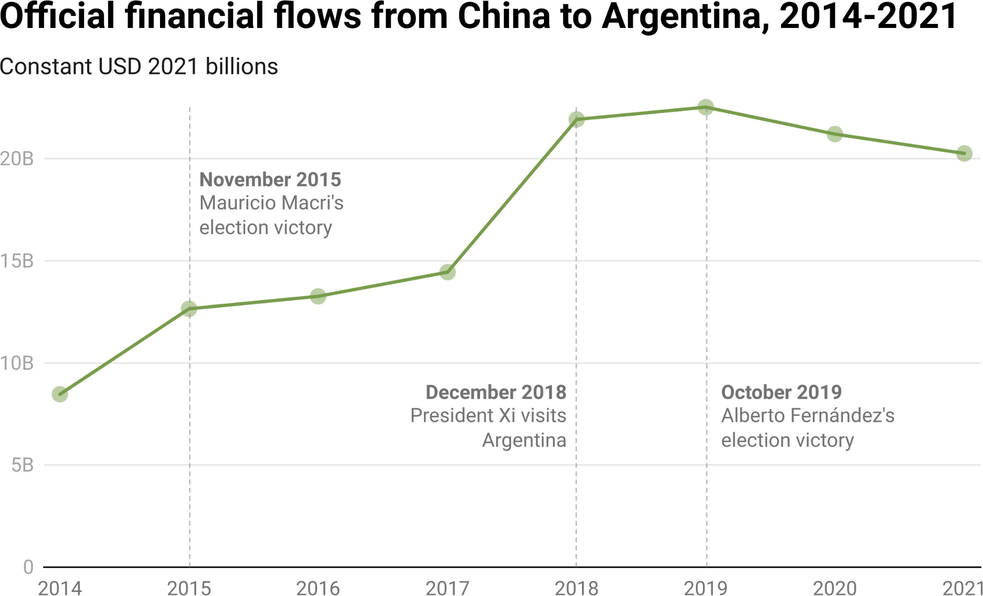

*Notes: AidData relies on OECD-DAC measurement criteria to make ODA and OOF determinations (as described in Section A-2 of the Appendix).*

At the same time, Argentina is geographically and economically proximate to the West. It has been a major non-NATO ally to the United States since 1998 (Center for Latin American and Latino Studies 2022). The U.S. is its third largest export and import market (The Growth Lab at Harvard University 2023).

Argentina has close, if complicated, relations with the IMF, which has provided tens of billions of dollars of credit to support the country. Argentina is also a vibrant democracy and one with a highly educated populace.

But Argentina has a history of pursuing strategic ties with ideologically-confounding partners in pursuit of its national agenda. During the late Cold War, the Argentine right-wing military junta had good relations with the Soviet Union to support its inﬂation-ridden economy (Schumacher 1981).

During the modern era of great power competition, Argentina’s status as a regional leader in Latin America and a G-20 economy has made it particularly important to both the United States and China, and it has pursued ties with both nations to beneﬁt itself. Nonetheless, our UNGA-based measure of elite support suggests that Argentina moved into closer alignment with China than the U.S. during the early BRI period. But the story begins a decade before the launch of the BRI.

##### The Kirchners and the BRI

During the 2003-2007 and 2007-2015 Peronist presidencies of Néstor Kirchner and his wife Cristina Fernández de Kirchner (CFK), U.S.-Argentina relations were shaky, inconsistent, and at times tense and hostile, although not cooperation-free (Sullivan and Nelson 2017). The Kirchners’ governments deepened ties with American adversaries, including Russia, Venezuela, Iran, and Cuba (Filkins 2015).

While these tensions with the United States grew and U.S. foreign policy focused on the Global War on Terror, the Kirchners deepened Argentina’s relationship with China, especially during CFK’s second term (Sullivan and Nelson 2016). China became the second largest export and import market for Argentina during the Kirchners’ presidencies (The Growth Lab at Harvard University 2023). During CFK’s ﬁrst term (December 2007 to December 2011), ofﬁcial ﬁnancial commitments from China to Argentina amounted to only $1 billion. However, during her second term (December 2011 to December 2015), ofﬁcial ﬁnancial commitments from China to Argentina skyrocketed to $23.9 billion.[355]

**Figure 4.12**

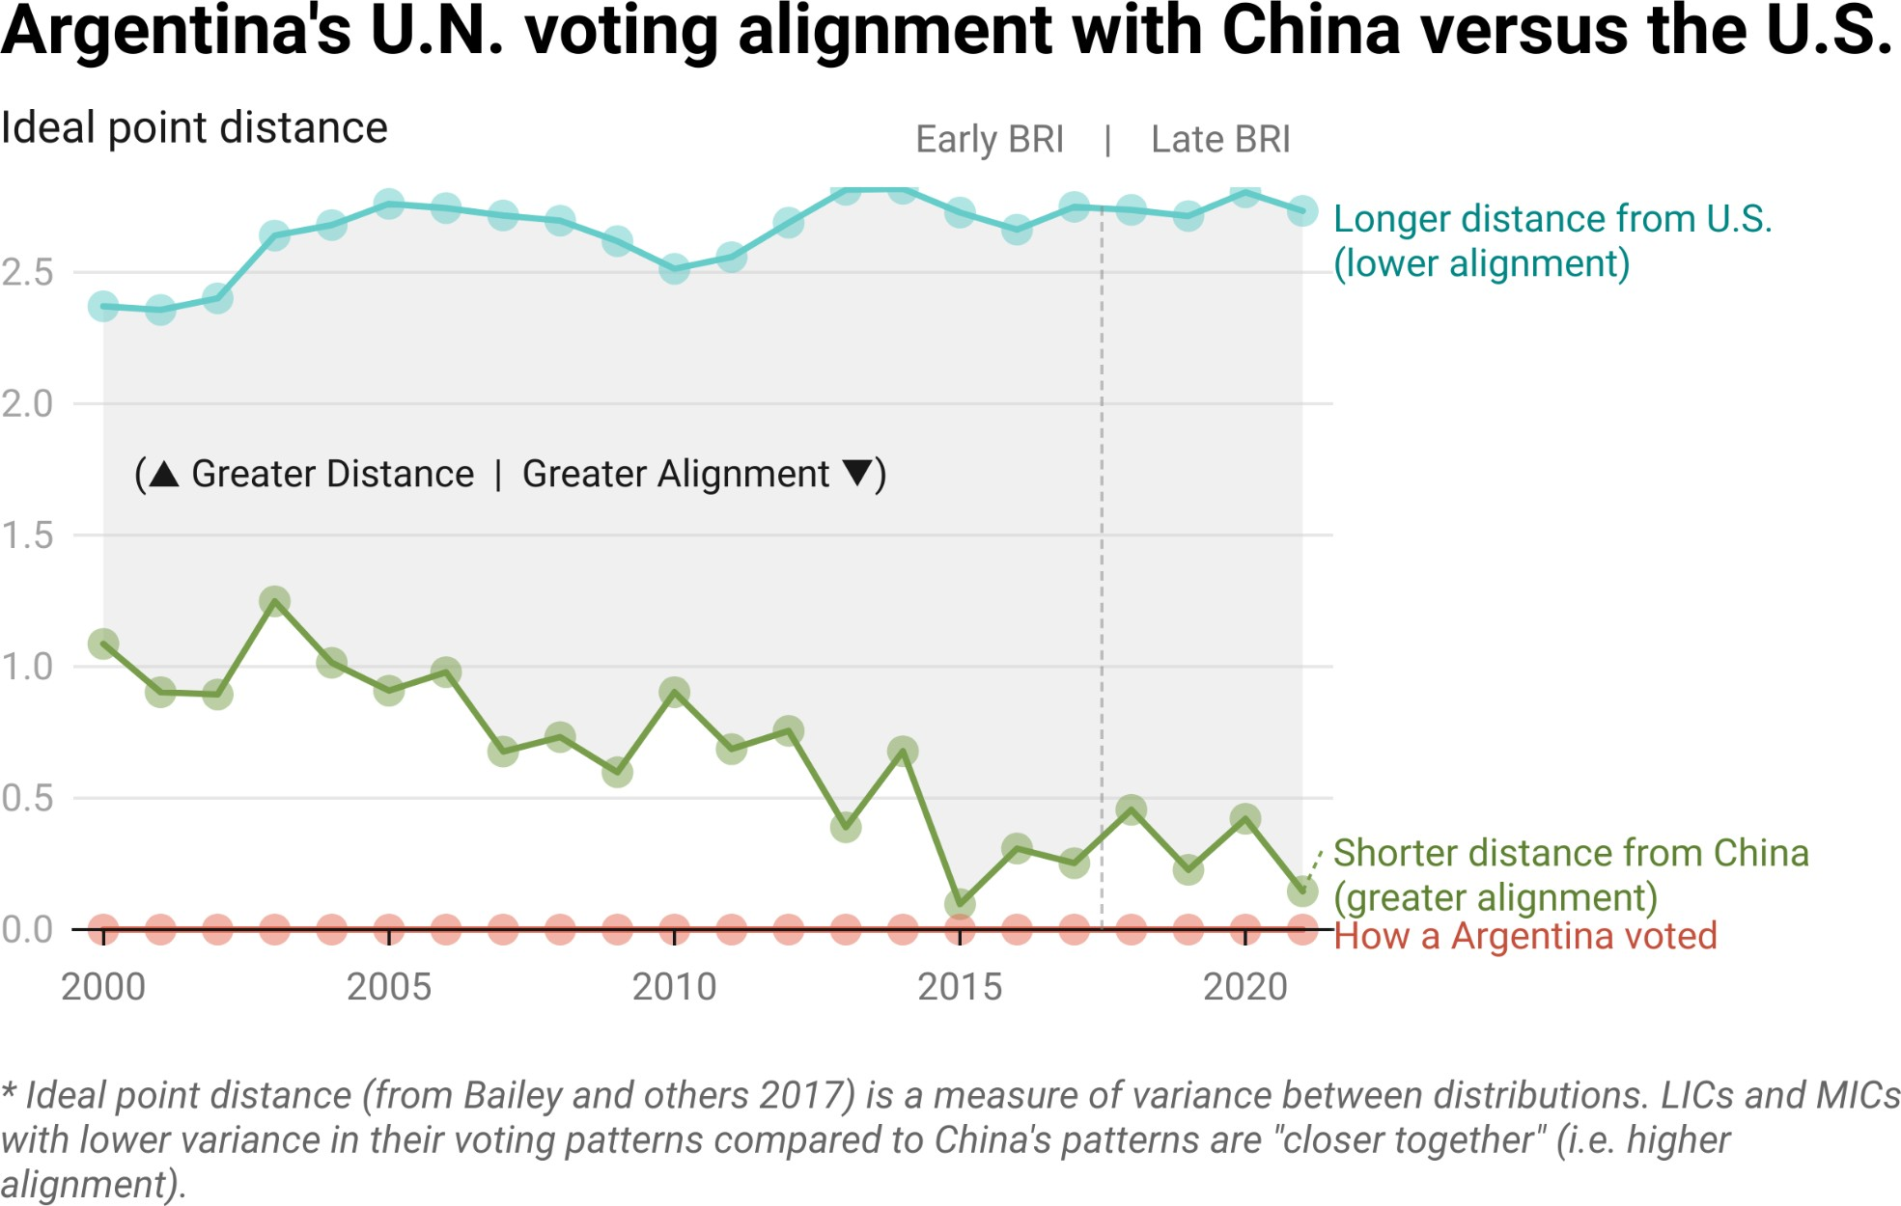

*Notes: See Box 1b for more detail on this measure.*

Figure 4.12 documents trends in Argentina’s level of UNGA voting alignment with China and the U.S between 2000 and 2021. The inﬂuence of Kirchnerist presidencies is evident. Argentina was never further away from China—from a foreign policy alignment perspective—than in 2003. Then, under the Kirchners’ presidencies, Argentina steadily moved into closer alignment with China, a trend that intensiﬁed during the early BRI period.

Argentina’s ties to China strengthened during CFK’s second term, which coincided with the beginning of the BRI. In late 2014, several Chinese state-owned banks green-lit a $4.71-billion syndicated loan for the 1,740 MW Néstor Kirchner and Jorge Cepernic Hydroelectric Power Plant Construction Project (KCHP Project), a twin dam of great personal signiﬁcance to CFK, as it was named in part after her late husband who died in 2010 (Lucci 2019).[356] CFK described the project as “the most important hydroelectric project” in Argentina’s history and served as its major patron (Watts 2015). The EPC contract was awarded to China Gezhouba Group as part of a wider consortium with two Argentine companies.

The dam project combined Peronist political goals (infrastructure-driven nation-building) with CFK’s personal political goals (developing the Santa Cruz

Province, the familial and political core of Kirchnerism) and the principles of the BRI (infrastructure to spur global development and trade). Argentina’s leadership was well-positioned to leverage large-scale ﬁnancing from China to support its agenda. For Beijing, the project represented an opportunity to promote the BRI and pursue its soft power objectives.

On July 30, 2014, two days before signing of the loan agreement for the KCHP Project, the Government of Argentina defaulted on its foreign bond repayment obligations (von Hoffman 2014). At the time, Argentina was experiencing a recession, a currency devaluation, and high levels of inﬂation. Earlier that month, on July 18, 2014, during Xi Jinping’s visit to Buenos Aires, the People’s Bank of China (PBOC) and the Central Bank of Argentina (BCRA) extended an RMB 70 billion (around $11 billion) bilateral swap agreement for the promotion of trade, use of the renminbi, and the bolstering of Argentina’s foreign exchange reserves (Arnold 2023). Later that year, the BCRA activated the swap arrangement, drawing down RMB 14.2 billion between October and December. Then, in 2015, it again drew down RMB 70 billion. The PBOC swap line helped rescue Argentina without any signiﬁcant involvement from Western powers. This was signiﬁcant because the default originated from an Argentine refusal to meet an

U.S. court-mandated repayment to a “vulture fund” (Shortell 2014).

The fact that China was willing to provide a large amount of credit during a period of crisis convinced some local elites that China could be a viable alternative to the West. After its 2001 default, Argentina had been isolated from international capital markets, so the emergence of China as a major international lender was a major boon, one that would allow the country to reduce its dependence upon the IMF and Western sources of funding. The availability of

Chinese credit could also be leveraged to secure more favorable offers from the West.

Partnership with China also offered domestic beneﬁts that could help CFK’s Justicialist Party remain in power. In exchange, China beneﬁted from an administration in Buenos Aires that was more willing to adopt foreign policy positions that it favored. By 2015, the UNGA voting alignment data shows that Argentina’s ideal distance from China reached its closest point across the entire 22-year period (at 0.0968).

Given the pro-China orientation of CFK’s Justicialist Party, Beijing was willing to support the incumbent by authorizing multiple drawdowns under the PBOC swap line to stabilize the economy.[357] Nevertheless, the Justicialist Party candidate, Daniel Scioli, who had been expected to win by a large margin, lost the 2015 election by 3 percentage points (BBC News 2015). The winner was a conservative businessman, Mauricio Macri. During his campaign, Macri expressed his desire to improve ties with the U.S. and European Union. Macri never directly voiced an anti-China position. In fact, he publicly stated the importance of maintaining good relations. But he did signal that contracts signed by CFK’s administration with Chinese companies required review for corruption and insufﬁcient “technical details.” CFK’s personal involvement in the KCHP Project had been a source of domestic political grievance that the new administration wished to rectify (Center for Latin American and Latino Studies 2022).

After years of heavy ﬁnancing during CFK’s years, from Beijing’s perspective, the prospect of an Argentinian repositioning toward the West would be a policy failure. The fact that Macri’s accession came in the midst of a wave of new center-right governments across Latin America likely ampliﬁed this concern (Center for Latin American and Latino Studies 2022).

China’s suspicions about this matter were not ill-founded. Under the Macri administration, U.S.-Argentina relations were much closer than when his predecessors were in power.[358] Furthermore, in 2018, the Macri administration negotiated the largest IMF loan ever—$57.1 billion—to support the country’s economy (Sen 2018).

Relations with China were not straightforward at ﬁrst. In late December 2015, Macri suspended the twin dam (KCHP) project on environmental grounds (Lucci 2019).[359] This triggered concerns from the Chinese lenders, which had already disbursed $950 million. On March 10, 2016, CDB sent a letter on behalf of the other members of the loan syndicate to Argentina’s ﬁnance ministry and warned of legal and political consequences of project suspension: *"[the KCHP Project and the Belgrano Railway Modernization Project are] major projects promoted by the Chinese parties in the same period of time in Argentina and each... [of the loan agreements for the two projects] contain 'cross default' provisions."* In effect, CDB told the Argentine authorities that they could not cancel the KCHP project without canceling the Belgrano railway project (Gelpern et al. 2022).[360]

In April 2016, after meeting with Xi in Washington D.C., Macri announced that the KCHP Project would proceed, although it would be modiﬁed to minimize negative environmental impacts (Koop 2016). Then, in December 2016, the Supreme Court of Argentina suspended construction until an environmental impact assessment was completed and a public hearing was held. Construction ultimately resumed in March 2018. Macri, after learning of China’s determination to see a project personally endorsed by Xi succeed, decided that canceling the project was not worth the potential consequences of alienating or antagonizing a major creditor (Patey 2017). He also took steps to develop a stronger relationship with China while maintaining good relations with the West. During the early BRI years of his presidency, ofﬁcial ﬁnancial commitments from China to Argentina remained substantial: $13.2 billion in 2016 and $14.4 billion in 2017.

[https://www.dropbox.com/s/q6s26ninx4ldnes/Cross-Default%20Letter%20from%20China%20Development](https://www.dropbox.com/s/q6s26ninx4ldnes/Cross-Default%20Letter%20from%20China%20Development%20Bank%20to%20the%20Government%20of%20Argentina%2010%20March%202016.pdf?dl=0)

##### The late BRI period under Macri and Fernández

Argentina saw further growth in ﬁnancial support from Beijing during the late BRI period (2018-2021). Average annual ﬁnancial commitments from China during this period amounted to $21.4 billion. Most of this funding was provided via PBOC swap line drawdowns for balance of payments support.[361] By the time Macri exited ofﬁce in December 2019, Argentina’s RMB swap debt represented 50.5% of the country’s total foreign exchange reserves (see Table 4.5).

**Table 4.5**

## Estimated percentage of Argentina’s foreign currency reserves derived from PBOC swap facility

|  |  |  |  |
| --- | --- | --- | --- |
| **Year** | **Total reserves (USD billions)** | **Amounts outstanding under PBOC swap facility**  **(USD billions)** | **Estimated percentage of reserves originating from PBOC swap facility** |
| 2009 | $48.01 | $0 | 0% |
| 2010 | $52.21 | $0 | 0% |
| 2011 | $46.27 | $0 | 0% |
| 2012 | $43.22 | $0 | 0% |
| 2013 | $30.53 | $0 | 0% |
| 2014 | $31.41 | $2.32 | 7.39% |
| 2015 | $25.52 | $10.78 | 42.25% |
| 2016 | $38.41 | $10.07 | 26.22% |
| 2017 | $55.31 | $10.75 | 19.44% |
| 2018 | $66.22 | $18.96 | 28.65% |
| 2019 | $44.88 | $18.60 | 41.46% |

|  |  |  |  |
| --- | --- | --- | --- |
| **Year** | **Total reserves (USD billions)** | **Amounts outstanding under PBOC swap facility**  **(USD billions)** | **Estimated percentage of reserves originating from PBOC swap facility** |
| 2020 | $39.40 | $19.89 | 50.49% |
| 2021 | $39.65 | $20.40 | 51.47% |

*Notes: This table shows the estimated percentage of Argentina’s foreign currency reserves that originated from the PBOC swap facility between 2009 and 2021. The data on total reserves are from the World Bank and include gold reserves. Amounts outstanding under the PBOC swap facility are from Horn et al (2023a). All amounts are reported in nominal USD.*

Despite the initial challenges, Macri eventually became a valued partner to China, as demonstrated by the increase in the swap line, Xi’s visits, and various trade agreements, including the opening up of China to Argentina’s soymeal livestock feed exports in September 2019 and lower barriers to beef and sheep exports (Koop 2018, Bronstein and Heath 2019). Macri took measures to join the China-backed Asian Infrastructure Investment Bank (AIIB) in 2018, which only became ofﬁcial in 2020. Also, while Argentina did not ofﬁcially join the BRI until the next administration, Macri was one of only two heads of state from Latin America to participate in the ﬁrst Belt and Road Initiative Forum in 2017 (Center for Latin American and Latino Studies 2022).

Beyond PBOC swap line borrowings, signiﬁcant collaborative activities with China during Macri’s presidency included the General Roca Railway Equipment Acquisition Project, which received a $236-million buyer’s credit from CDB and supported a commercial contract with state-owned CRRC Qingdao Sifang; the National Road Line B (Corredor B Toll Road) Project, which was supported by a $1.18-billion syndicated loan from three banks, including the Bank of China and ICBC, to a Argentine-Chinese joint venture responsible for the construction and operation of the road; and the 312 MW Caucharí Photovoltaic Power Plant Project, ﬁnanced by a $331.5-million China Eximbank loan. Macri’s personal pragmatism and the prospect of what China could still offer helped foster a good relationship.

China’s experience with Macri left Beijing with an optimistic outlook for the future of Argentine-Chinese relations. Despite Macri’s pro-Western views and actions and initial caution toward China, under his leadership Argentina grew even closer to China. If China could thrive in Argentina under a conservative, pro-Western president, then it could thrive under almost any conceivable Argentine president—especially if the Kirchnerists returned to power, who had deepened the relationship in the ﬁrst place. China had demonstrated during both CFK and Macri’s presidencies that it was a reliable, critical partner to the Argentine government for the country’s economic stability and willing to negotiate if necessary, leaving little willpower among Argentine elites to alienate or antagonize a valuable partner; thus, China had turned Argentina into a “safe bet” for the foreseeable future.

Macri’s center-right government ultimately proved insufﬁciently popular by the time of the 2019 Argentine general elections, due to economic troubles. The Kirchnerists returned to power with president Alberto Fernández and former president, now vice president, Cristina Fernández de Kirchner (no relation).

During his campaign, Fernández often discussed China, arguing that Macri did not appreciate China enough. Additionally, Fernández met with Zou Xiaoli, the Chinese Ambassador in Argentina, and sent several of his foreign policy advisors to the embassy in the weeks prior to the election. Observers expected that under the Fernández administration, relations would be close, with China’s projects in the country expected to be boosted (Koop 2019). As a demonstration of the importance of relations, Fernández’s government appointed Sabino Vaca Narvaja, son of one of the founders of the Montoneros guerillas and the brother-in-law of CFK’s daughter, as ambassador to China and assigned a general to serve as the defense attache, something previously only done for the U.S. (Ellis 2021).

Examining the data on ﬁnancial commitments from the 3.0 version of AidData’s GCDF dataset during the latter half of the late BRI period, there is little evidence of differential treatment across the Macri and Fernández administrations, with Argentina receiving $21.2 billion in 2020 and $20.2 billion in 2021. However, even though relations seemed poised to grow, the Fernández administration’s relations with China reportedly stagnated because of issues on the Argentine side (Giusto and Harán 2023). Numerous pledged or committed projects with China never reached implementation because of currency controls, protectionism, bureaucratic bungling, and inconsistent policymaking from Argentina’s national leadership (Economist 2023).

An example is the Atucha III Nuclear Plant Project. First pledged in 2014 during CFK’s second term, it went through multiple rounds of negotiations with the Macri administration but never made solid progress. Soon after his victory, Fernández announced that the project would proceed. In February 2022, Argentina signed an EPC contract with China National Nuclear Corporation, only for Argentina to ask China to 100% ﬁnance the project in April 2022 (as opposed to the standard 85% maximum). More negotiations and requests for modiﬁcations followed throughout the year, leaving the project on shaky grounds (Bernhard 2022). Atucha is not an outlier. Between 2018 and 2021, China pledged $664.6 million of additional ﬁnancing, but none of these pledges had become formal commitments by 2023, and an additional set of projects worth $146 million were suspended.[362]

Even if Fernández was not as interested in strengthening Sino-Argentine ties, Fernández, being a close Kirchner ally, was politically aligned with China. In February 2022, he visited Beijing and signed an agreement to join the BRI (Giusto and Harán 2023). China also issued a statement in support of Argentine claims to the Falkland Islands (known as Las Islas Malvinas in Argentina) (Rey 2022). At the UNGA, he continued the overall pattern established by his predecessors, bringing Argentina into closer voting alignment with China.[363]

The large volume of ofﬁcial ﬁnancing from China to Argentina—especially in the form of government-sustaining currency swap drawdowns, and in addition to foreign direct investment and trade ties—has made China a critical ﬁnancial partner for Argentina. During the early BRI period, which saw the last part of CFK’s rule and the initially difﬁcult, but soon productive, beginning of the Macri administration, Beijing realized how strong its foothold was, to the point that it could feel conﬁdent that Argentine elites would not endanger relations, turning it into a “safe bet” amongst all recipients for friendly elite alignment with China.

Based on the close relations under the Macri presidency and political alignment during the Fernández presidency, Beijing appears to have correctly predicted the course of bilateral relations. The overall trend has been one of increasing UNGA voting alignment between China and Argentina and an expanding envelope of Chinese aid and credit.

##### Entrenchment as a goal of soft power

During the BRI era, in light of good bilateral relations, China has provided meaningful economic support to Argentina. Because the economy is the single most important electoral issue and Argentina’s dependency on China is high, major political parties have strong incentives to maintain good relations with Beijing. Macri experienced the downside of being seen as uncooperative toward Beijing, forcing him to course correct toward a friendlier path. But as great power competition between China and the West intensiﬁes, Argentina’s ability to maintain good ties with both sides is becoming limited. A case in point is the ongoing U.S. push to sell its own F-16 ﬁghter jets to Argentina, in order to prevent it from purchasing the cheaper Chinese-designed and

Pakistani-manufactured JF-17 jets (Buenos Aires Times 2023).

However, a candidate in the Presidential run-off election who received 30% of the popular vote during the ﬁrst round is far-right populist and libertarian economist Javier Milei. In August 2023, Milei announced his intentions to freeze relations with China, calling its government “an assassin” and describing his proposed foreign policy as a “ﬁght against socialists and statists” (Brandimarte and Tobias 2023). Analysts have compared Milei to Donald Trump and former Brazilian president Jair Bolsonaro, who both used anti-China rhetoric to bolster their electoral campaigns (Shi 2023). Should Milei win the election, Argentina’s foreign policy would likely shift into substantially closer alignment with the United States. Beijing may hope that as president Milei would soften his rhetoric on China once in ofﬁce like Macri did, but regardless, China would likely prefer another candidate.[364]

In the run up to the ﬁrst-round elections in October 2023, Chinese ofﬁcial sector entities provided additional resources to Argentina, presumably to bolster the campaigns of candidates it deems least problematic. In June 2023, Sergio Massa, the incumbent economy minister and a leading candidate, visited Beijing, where he struck deals on Argentine exports, $3.05 billion in ﬁnancing for various projects, and, most importantly, an extension and expansion of the PBOC swap line (Alcoba 2023). Based on China’s past decision making in Argentina and an empirical pattern of commiting more funds in election years around the world, more agreements and commitments are likely forthcoming (Dreher et al. 2019).

But the same logic of China being too big to push in Argentina may also apply to its relationship with the U.S. Argentina lacks the leverage, or willingness, to become a true American adversary akin to Cuba or Venezuela. Factors like geographic proximity, democratic afﬁnity, and cultural synergy all advantage the

U.S. over China. In 2021, 59.48% of Argentinians approved of the U.S. government, according to Gallup, as compared to only 32.65% for China. The economic dimension is also noteworthy. While not nearly as large as China, the

U.S. is still one of the major trade partners of Argentina. It is also the single largest shareholder at the IMF, where Argentina is the single largest debtor. Under its new government in 2024, Argentina’s foreign policy will have to carefully tread between ties with the U.S. and China, both of which are critical for its future economic prospects.

### Section 5: Beijing’s approach to reputational risk management

In this chapter, we have provided statistical and case study evidence that China—like other foreign powers—makes adjustments to its international development ﬁnance portfolio in response to soft power gains and losses on the ground. It is taking reactive and proactive measures to manage reputational risk.

clauses which we don’t know about and we are ready to re-examine them” (Stott and Nugent 2023).

There are ﬁve key takeaways from our analysis. First, on three different measures of soft power (that capture gains and losses in public opinion, media sentiment, and elite support), Beijing devoted nearly two-thirds of its entire international development ﬁnance portfolio during the late BRI period to “toss up” countries. These countries represent competitive jurisdictions where neither China nor the

U.S. opened up an insurmountable lead vis-à-vis its principal rival.

Second, in settings where China recently made reputational gains at the expense of its principal competitor, it doubled down with additional aid and credit—i.e., it sought to maintain and build upon momentum.[365] The fact that Beijing is redirecting aid and credit to battleground countries where it has recently gained advantage challenges a popular belief among Sinologists: that the bureaucratic machinery responsible for Beijing’s overseas development program is fragmented, uncoordinated, and inattentive to changing reputational dynamics on the ground.[366]

Third, China does not have much of an appetite for reputational risk. It consistently allocated a lower-than-expected share of its international development ﬁnance portfolio to “moonshot” countries (dedicating between 16% and 27% less than expected for each soft power measure, see Figure 4.5). These are countries where its principal rival has momentum on its side. China rarely seeks to woo indifferent or antagonistic countries with aid and credit, but instead prioritizes countries that are already moving in its direction. A separate, but related, point is that, when reputational assets turn into reputational liabilities (as we saw in the Zambia case study), Beijing mostly disengages from discussions about new projects and ﬁnancial commitments and refocuses on managing risks within its existing portfolio of grant- and loan-ﬁnanced projects.

Fourth, as case studies of Bangladesh and Argentina demonstrate, political transitions in host countries are critical moments when the nature, level, and pace of China’s engagement can change signiﬁcantly. Beijing understands that it can make major reputational gains or suffer major reputational losses during these windows, and it has demonstrated a willingness and ability to use instruments of state power to protect its interests when such junctures arise. During the transition from the Kirchner administration to the Macri administration, a consortium of Chinese state-owned policy and commercial banks invoked a cross-default clause in a loan agreement with the Argentine Ministry of Finance to block the newly-elected president from following through on his electoral pledge to suspend environmentally risky projects, which could have jeopardized a $5.5 billion dam construction contract that was previously issued to China Gezhouba Group Company Limited. Conversely, when new leaders come to power and take a less adversarial posture (like Bangladesh’s Sheikh Hasina and Zambia’s Edward Lungu), our ﬁndings suggest that Beijing often seeks to cement bilateral relations by helping incumbents take credit for high-proﬁle projects.[367] It does so by, among other things, approving new ﬁnancial commitments for projects that were previously under consideration, organizing groundbreaking ceremonies for previously approved projects that had not yet commenced, and providing state-sponsored media coverage of recently completed projects.[368] This strategy is especially relevant in democratic countries where elections are more competitive, as in Zambia where incumbent performance at the ballot box is linked to perceived effectiveness at delivering big-ticket infrastructure projects that can create jobs and stimulate short-term economic growth.

Finally, for those who make and shape policy in Western capitals, a key insight from this chapter is that Beijing tends to disengage rather than double down in countries where there are strong indications of BRI buyer’s remorse. These are jurisdictions where Beijing’s competitors may be able to lure countries back into the West’s orbit by focusing on their own areas of comparative advantage.

However, doing so would require that Western powers act quickly when these windows of opportunities arise and adapt their programming to address the unmet needs of partner countries.

# Annotation

305 On this point, see Goldsmith et al. (2014), Blair et al. (2022a), Wellner et al. (forthcoming), and Asmus et al. (forthcoming).  
  
306 A popular deﬁnition of soft power is “the ability to achieve goals through attraction rather than coercion” (Nye 2004: x).  
  
307 Gelpern et al. (2022: 26, emphasis added) report a similar episode involving “a video obtained and released by investigative journalists that revealed the terms of Ecuador’s multi-billion dollar oil-backed debt to CDB. The release of the video shortly after the deal was signed prompted public debate about the new borrowing [...]. In response, the head of CDB’s Resident Mission in Ecuador wrote to his counterpart in Ecuador’s Ministry of Finance, complaining about the borrower’s apparent breach of [a] conﬁdentiality letter, called on the Ecuadorian government to launch a leak investigation and demanded that it take measures to mitigate the reputational damage to CDB caused by the video. The CDB letter also implicitly threatened to withhold future ﬁnancing if the borrower did not adequately address the incident.”  
  
308 Another interesting example is the policy position that many African governments take on China’s treatment of Uyghurs living in Xinjiang Province. Rather than jumping on the Western bandwagon and criticizing China for its alleged human rights abuses, African governments increasingly push back, arguing that “Western forces [are] hyping up the so-called Xinjiang-related issues [to] serve their own ulterior motives” (Olewe 2021).  
  
309 According to Halper (2010), “China’s governing model is more appealing to the developing world and some of the middle-sized powers than America’s market-democratic model. Given the choice between market democracy and its freedoms and market authoritarianism and its high growth, stability, improved living standards, and limits on expression—a majority in the developing world and in many middle-sized, non-western powers prefer the authoritarian model.”  
  
310 An important feature of China’s model is its “portfolio approach.” Chin and Gallagher (2019: 256) explain that “[w]hereas Western-backed [development ﬁnance institutions] and [multilateral development banks] conduct individual project ﬁnancing, China’s policy banks, at home and abroad, take a [...] portfolio approach and ﬁnance what they refer to as ‘strategic credit spaces’ where bundles of loans or lines of credit are issued for an array of coordinated and corresponding projects.” Coordinated public investment strategies have a rich intellectual history related to “big push” theory (Rosenstein-Rodan 1943) and “growth pole” theory (Perroux 1950; Hirschman 1958). According to Chin and Gallagher (2019: 251), “[s]ome in the senior ranks of the Chinese state policy banks have drawn inspiration from [“big push” theory], including the former chief economist at the China Development Bank [CDB], Lixing Zou, who saw CDB as having played such a coordinating role within the Chinese growth miracle.”  
  
311 In Africa, its primary export, CGTN Africa, has been less successful in bringing China’s message to the world than BBC Africa due to a lack of quality stafﬁng (Zhang and Ong’ong’a 2021).  
  
312 Building upon these model results, Wellner et al. (2023) estimate the country-speciﬁc magnitudes of these public opinion effects by assuming a counterfactual scenario in which the Chinese government equally distributed development projects across all countries. If Cambodia received 30 Chinese development projects (the average number of projects over the 2006-2017 period of study) rather than the 91 that it actually received, the authors estimate that China would have suffered a 12.55 percentage point loss of public support in that country.  
  
313 We thank Axel Dreher, Andreas Fuchs, Austin Strange, and Mike Tierney for generating and sharing supplementary evidence derived from a statistical model in the ﬁfth chapter of their book Banking on Beijing.  
  
314 Previous research demonstrates that foreign powers other than China use aid and credit to inﬂuence the foreign policy positions of developing countries (Alesina and Dollar 2000; Kuziemko and Werker 2006; Vreeland and Dreher 2014; Rose 2018).  
  
315 China’s system of governance is often characterized as “fragmented authoritarianism,” where multilevel power centers exist, each with their own listening posts, interests, and decision-making processes, which can make it difﬁcult to generate uniﬁed positions and approaches (Mertha 2009). Analysts have also argued that “fragmented authoritarianism” affects the execution of China’s overseas development program, where multiple stakeholders associated with the state (companies, banks, diplomatic missions, etc.) are advancing their own interests without necessarily following a coherent strategy organized by a central coordinating agency (Ye 2021, Lee 2020). A key objective of this chapter is to probe the plausibility of the hypothesis that Beijing is capable of formulating coherent responses to the competitive (soft power) challenges that it faces in the Global South.  
  
316 For example, in an empirical examination of competition between China and India in 2,333 provinces across 123 countries between 2007 and 2014, one study ﬁnds that an “increase in the probability of a new Indian Exim Bank loan in response to new Chinese development projects is more pronounced when  
  
popular opinion in the recipient country is relatively more favorable about India than about China” (Asmus et al. forthcoming: 26, emphasis added). The same study provides evidence that this effect “is driven by the difference in public sentiment toward India and China rather than by the absolute levels of public support for India in these countries” (Asmus et al. (forthcoming: 26-27).  
  
317 For instance, when a country suffers from a major natural disaster induced by global climate change and levels of foreign assistance are lacking, public resentment can increase toward all outside forces, as well as domestic institutions.  
  
318 Table A13 provides the country-speciﬁc double delta scores for each soft power measure.  
  
319 Vadlamannati et al. (2023: 16) provide evidence that the “BRI prompts the largest positive U.S. response when China is engaged with the target country but not yet dominant.” The existing empirical literature does not provide conclusive evidence about whether Beijing follows a strategy of balancing, bandwagoning, or hedging.  
  
320 The “Toss-ups (leaning China)” category description is admittedly imperfect when applied to the elite (UNGA voting) alignment measure, since the U.S. made gains at the expense of China in a substantial number of the countries that fall within the category.  
  
321 Before and after his 2016 electoral victory, President Trump’s ﬁery “America First” rhetoric and divisive personal views raised worldwide concerns about his country’s commitment to maintaining global leadership. His electoral agenda included proposals to impose tariffs on Chinese imports into the U.S. for “protecting American jobs” which raised concerns about a new “trade war” that would ultimately hurt developing countries (Kucik 2017). At the same time, Xi was seeking to position China as a leader on the world stage. When he ﬁrst introduced the BRI, he focused on creating “win-win” partnerships with host countries through big-ticket infrastructure projects.  
  
322 As we describe in Box 1b in Chapter 1, we restrict our analysis to media coverage about Chinese and American governments, rather than the countries overall, to ensure that we focus on the activities of the ofﬁcial sector. In most host countries, an array of Chinese and American private companies and nonproﬁts engage in activities that are wholly or partially independent of their home country’s ofﬁcial policies and approaches.  
  
323 More often than not, we ﬁnd that China and the U.S. vote differently at the UNGA. Since 2000, they have only taken the same position on 14.5% of all resolutions. This misalignment becomes worse in certain issue areas, such as a 7.8% alignment on human rights resolutions and a 4.6% alignment on the Palestinian conﬂict. There is much closer alignment, 19.5%, between China and the U.S. on resolutions concerning nuclear weapons and materials and arms control and disarmament, consistent with their nuclear statuses.  
  
324 Across the global distribution, the average double delta “idealpoint” distance was -0.02.  
  
325 The cross-country aid allocation literature generally uses two variables to measure economic need: income and population size (e.g., Alesina and Dollar 2000; Dreher et al. 2022). However, income is used to account for varying levels of economic need across HICs and LICs/MICs. Given that our analysis is exclusively focused on LICs/MICs (i.e., only countries with relatively low levels of income), we rely on population size to capture cross-country differences in economic need.  
  
326 Between 2018 and 2021, the 3.0 version of AidData’s dataset captures development ﬁnance commitments to 138 countries and territories.  
  
327 As we will soon explain, there is some evidence that, in order to safeguard its geopolitical interests in Bangladesh (where it forged a robust partnership with Prime Minister Sheikh Hasina), Chinese state-owned ﬁnanciers and implementation agencies accelerated the pace of project commencement and completion ceremonies during election season.  
  
328 For context, the same set of countries that were classiﬁed as toss-up (leaning China) or toss-up in our analysis received 21% of China’s total development ﬁnance portfolio in the pre-BRI period (2000-2013), and 28% during the early BRI period (2014-2017).  
  
329 For context, the same set of countries that were classiﬁed as moonshot in our analysis received 31% of China’s total development ﬁnance portfolio in the pre-BRI period (2000-2013), and 12% during the early BRI period (2014-2017).  
  
330 During this time, Prime Minister Sheikh Hasina has presided over both stellar economic development performance and growing authoritarianism. Most of the late-BRI ﬁnancing has focused on large-scale infrastructure projects related to transportation and energy.  
  
331 According to Table 4.2, the largest positive delta (+22 pp) between expected and observed Chinese development ﬁnance allocations to countries is observed in the safe bets category.  
  
332 For each soft power measure, we selected a country that fell within a category (safe bet, toss-up, and moonshot) that China prioritized during the late BRI period. To maximize generalizability, we also selected countries from different regions and with varying levels of economic development.  
  
333 Many African leaders complained about American neglect, indifference, or even disdain during the Trump administration.  
  
334 Approval ratings are taken from the Gallup World Poll. China’s lending commitments to Zambia in 2019 and 2020 amounted to only $143.7 million.  
  
335 China’s footprint in Zambia’s healthcare system goes beyond hospitals and equipment, with medical teams from Hunan province serving on 22 tours in Zambia since 1978.  
  
336 With an average annual allocation of only $423 million, U.S. development ﬁnance ranged from a low of  
  
$399 million in 2019 to a peak of $548 million in 2017.  
  
337 Given the relative stability of aid ﬂows from Washington, Zambian public opinion appears to be primarily driven by changes in the White House. After peaking at 92.5% during the ﬁrst year of the Obama administration, it subsequently fell to just 66.7% in 2017 after Trump took ofﬁce, in line with the “Trump effect” that hurt U.S. popularity globally.  
  
338 According to the CIA’s World Factbook, with an area of 752,618 square kilometers, Zambia is the world’s 40th largest county, but its road network of 67,671 kilometers is the 70th most extensive in the world. However, only 14,888 kilometers, or 28%, of Zambia’s roads are paved. This means that its paved road density is only 0.02 kilometers per square kilometer, signiﬁcantly lower than other developing countries like India (0.7) and Brazil (0.6).  
  
339 Throughout this period of high infrastructure activity, China’s signature public health engagements continued through medical team visits, equipment and medical supplies donations, and interventions to combat infectious diseases (Dolan et al. 2023).  
  
340 Between 2000 and 2021, the ESG risk prevalence rate in China’s grant- and loan-ﬁnanced infrastructure project portfolio was 56% in Zambia (see Table A12).  
  
341 The Sata government also launched an investigation of the 750MW Kafue Gorge hydropower project to determine if adequate transparency and ﬁnancial controls were in place to monitor performance.  
  
342 Dr. Chitala claims in his book that Zambia’s Secretary to the Cabinet Dr. Roland Msiska and later Dr. Simon Miri and his deputy, former Deputy Finance Minister and Bank of Zambia Governor Patrick Mvunga, placed extraordinary pressure on ZESCO (the country’s state-owned power utility) to accept an on-lending agreement for Phase II of the Smart Zambia National ICT Development Project. He writes that “it was obvious that some people had either already beneﬁted from the deal or were being prevented from beneﬁtting. Some of the members of the [ZESCO] management expressed genuine fear of the situation and requested for my protection.” He also writes that “[t]he President [of Zambia] advised me to cancel [an upcoming ZESCO Board] meeting which I gratefully did as I had planned to resign from the Board if the Board members resolved in the afﬁrmative to accept the on-lent loan. […] I had earlier made up my mind that if the board accepted that [ZESCO] receive the USD 392 million as on lent to [ZESCO] by the Ministry of Finance knowing that [ZESCO Limited could not accommodate the loan on its balance sheet and further knowing that the loan was essentially a way of defrauding Zambia, I would respectfully resign as chairman and board member of ZESCO Limited. […] It was common knowledge that the more than US$ 60 million that the Ministry of Finance released as its 15% counterpart contribution funding for the loan was not only wrongly released but was also grossly abused and that many people may have received bribes on that deal and hence the pressure on ZESCO to accept the USD 392 million on-loan let instructions. […] It was apparent that since government money had been expended without any work to show for, this would add to the other scandals that the Auditor General used to publish as examples of abuse of public ofﬁce of trust or common theft of public resources by politicians and public servants” (Chitala 2022).  
  
343 Given that the loan was insured by Sinosure, the EPC contractor (Sinohydro Corporation Ltd.) sought compensation through an indemnity payment. In January 2021, Sinohydro Corporation Ltd. ﬁled an insurance claim with Sinosure, which in turn made an indemnity payment (worth $57.23 million) to Sinohydro Corporation Ltd. in May 2021. See Project ID#92289 and #57536 in the 3.0 version of AidData’s GCDF dataset.  
  
344 The rise of authoritarianism, which began during Sheikh Hasina’s second term (2009-2014) and was reinforced during her third term (2014-2019) with the Digital Security Act of 2018, has continued during her fourth term (2019-present). The opposition party (BNP), which accuses the government of using the judicial system to silence its critics and hatching plans to rig the January 2024 election, claims that the future of multi-party democracy is in jeopardy (Amnesty International 2023; Paul 2023).  
  
345 China’s ODA and OOF commitments to Bangladesh during this 22-year period focused on four sectors: energy ($10.3 billion), transport ($6.3 billion), industrial development ($1.9 billion), and ICT infrastructure ($1 billion). Beijing also supported a large number of education, health, and emergency response projects (with relatively small ﬁnancial commitments), particularly in crisis years such as the COVID-19 period.  
  
346 With scores of +4.7 and +3, China’s largest media sentiment advantage over the U.S. came in 2016 and 2017. Since then (2018-2022), the average tone of media sentiment about China has fallen to +1.1. This ﬁnding is consistent with empirical evidence that suggests the soft power beneﬁts of Chinese development projects are short-lived, with a signiﬁcant fading away of reputational beneﬁts in the medium- to long-term (Wellner et al. forthcoming).  
  
Annual average development  
  
Political Administration  
  
(2014-2018)  
  
(2019-present)  
  
347 Between 2000 and 2021, the ESG risk prevalence rate in China’s grant- and loan-ﬁnanced infrastructure project portfolio was 59% in Bangladesh (see Table A12).  
  
348 In Chapter 3, we discuss the governance risks associated with siting development projects in the home districts of political leaders. Also see Dreher et al. (2019, 2022).  
  
Treatment Plant  
  
Bridge Plant  
  
349 Bangladesh’s perceived level of corruption is among the worst in South Asia (Transparency International 2021).  
  
350 According to a poll undertaken by the International Republican Institute’s (IRI) Center for Insights in Survey Research (CISR) between March 1, 2023 and April 6, 2023, Sheikh Hasina enjoys a 70% public approval rating. However, approval of the opposition increased from 36% in September 2019 to 63% in March/April 2023 (CISR 2023).  
  
351 China has previously demonstrated that it is willing and able to fast-track infrastructure projects to help friendly political incumbents (e.g., Jansson 2013).  
  
352 Dreher et al. (2022) provide statistical evidence that when Beijing issues loans at or near market rates, it favors countries with high levels of political stability.  
  
353 Effective public debt management is one such example. Bangladesh currently has a manageable debt-to-GDP ratio of under 20% (World Bank 2023a).  
  
354 A bilateral currency swap (BCS) agreement is an agreement between the central banks of two countries to exchange cash ﬂows in different currencies at predetermined rates over a speciﬁed period of time. The party to the BCS agreement that draws down on the swap line becomes the borrower and its counterparty becomes lender. The currency of the borrower is held as collateral while the lender receives interest on the amount drawn down by the borrower until repayment is made. In principle, swap lines with the PBOC are designed to promote the use of RMB for trade and investment settlement purposes. However, in practice, they are mostly used to provide balance of payments support to borrowers with high levels of outstanding debt to China during periods of ﬁnancial distress (Horn et al. 2023a, 2023b). Nearly all PBOC swap borrowings carry de jure maturities of less than one year. However, PBOC swap debt is frequently rolled over, resulting in average de facto maturities of 3.5 years (see Box 3a in Chapter 3).  
  
355 These ﬁgures, as well as other ﬁgures that rely on precise dates, only include projects where the commitment dates within a given year are entirely unknown if the relevant measure [presidential term, months before an election, etc.] makes up more than half of the year; so for 2015, since CFK served as president for all but 21 days of the year, AidData includes commitments with entirely unknown dates as under her presidency.  
  
356 The unredacted loan contract was included in the How China Lends Dataset, Version 1.0 (Gelpern et al. 2022) and it is accessible in its entirety via https://www.documentcloud.org/documents/20484849-arg_2014_435.  
  
357 With the country’s economic problems a dominant issue during the campaign, inﬂation running around 25%, and currency reserves declining, Beijing’s ﬁnancial rescue package was useful to governing elites (GBH 2015).  
  
358 This was bolstered by the ideological synergy between Macri and Donald Trump. Macri’s Argentina supported the Trump administration’s campaign against Nicolás Maduro’s Venezuela (Wilkinson 2019).  
  
359 Between 2000 and 2021, the ESG risk prevalence rate in China’s grant- and loan-ﬁnanced infrastructure project portfolio was 44% in Argentina (see Table A12).  
  
360 The letter can be accessed in its entirety via  
  
%20Bank%20to%20the%20Government%20of%20Argentina%2010%20March%202016.pdf?dl=0.  
  
361 In July 2017, BCRA and PBOC extended the swap line by another three years; then, in December 2018, during Xi’s state visit to Argentina, BCRA and PBOC signed a deal to increase the swap line’s limit from RMB 70 billion to RMB 130 billion (around $19 billion) (Horn et al. 2023a). This agreement included a stipulation that PBOC could reject currency swap drawdowns if Argentina’s IMF standby agreement was suspended or canceled.  
  
362 In addition to projects that secured ﬁnancial commitments in the early BRI era—which do not have the excuse of COVID-19 as a delaying factor and had more opportunities to be formally committed—over $2.8 billion of ﬁnancing that had been pledged never reached implementation and projects worth $11 billion were suspended.  
  
363 In 2021, he achieved one of the closest ideal distances (0.1452) from China during our entire 22-year period of study.  
  
364 That being said, in October 2023, center-right candidate Patricia Bullrich announced that she would reverse President Alberto Fernández’s decision to join the BRICs bloc if elected. She also told the Financial Times that “[w]e believe that in some of the latest [Chinese] loans there are  
  
365 More speciﬁcally, we ﬁnd that Beiijing prioritized the provision of aid and credit to countries where it had experienced public opinion and media sentiment gains at the expense of the U.S. during the early BRI period, while it deprioritized toss-up countries where the momentum shifted in favor of the U.S. during the early BRI period.  
  
366 We thank Marina Rudyak for calling our attention to this point.  
  
367 On this point, also see Holslag 2011; Jansson 2013; DiLorenzo and Cheng 2019; Dreher et al. 2019; Anaxagorou et al. 2020; Strange 2023; Tang 2021; Kern et al. 2022.  
  
368 Wellner et al. (forthcoming) demonstrate that the completion of Chinese grant- and loan-ﬁnanced projects increases public support for the Chinese government and the host government.